Name of Faculty: Prof. R. S. Parihar
Designation: Associate Professor
Department: CE, LNCTS & LNCTE
Subject: Environmental Engg-I
Unit: 4
Topic: Sewerage Schemes & Design

UNIT – 4 Unit-04/ Lecture-01
Sewerage schemes and their importance
Unit-04/Lecture-01
Introduction & Definition
Definition of Sewage [RGPV June 11, 14 Dec 11]
The sanitary sewage includes excreta (i.e. waste matter eliminated from the body), domestic sewage (i.e. used water from home or community which includes toilet, bath, laundry, lavatory and kitchen-sink wastes) and industrial wastes. The improper disposal of human excreta and sewage is the major factor threatening the health and comfort of individuals where satisfactory sewerage systems are not available.

Blackwater is any waste from a toilet or urinal. It contains disease causing organisms that can result in human illness by direct contact or by consumption of affected fish and shellfish. It also contributes to the build-up of unwanted nutrients in ecosystems.
Greywater = wastewater other than blackwater= from sinks, showers, washing machines, dish washers =can be recycled on-site for uses such as toilet flushing, landscape irrigation and constructed wetlands & differs from the discharge of toilets which is designated sewage or blackwater to indicate it contains human waste.
IMPORTANT TERMS AND DEFINITIONS
- Refuse : Refuse is a general term used to indicate what is rejected or left out as worthless. It may be in liquid, semi-solid or solid form, anti many be divided into six categories : (i) garbage (ii) rubbish (iii) sullage (iv) scwagc (v) subsoil water and (vi) Storm water,
- Garbage : Garbage indicates the refuse. Ii includes waste paper, decayed fruits and vegetables, grass and leaves, and sweepings from streets, rnarkcts and other public places. Thus, garbage contains large amounts of organic and putritying matter.
- Rubbish : Rubbish indicates sundry solid wastes from offices, residences and other buildings. It also includes waste building materials, broken furniture, paper, rags etc. Generally, rubbish Is dry and is of combustible nature.
- Sullage : Sullage is a term used to indicate the wastewater from bath rooms, kitchens, washing places and wash basins etc. It does not create had smell since organic matter in it is either absent or is of negligible amount.
- Sewage: Sewage indicates the liquid waste from the Community. It includes sullage, discharge from latrines, urinals, stables industrial waste and also the ground surface and storm water that may be admitted into the sewer. It is extremely putrescible; its decomposition produces large quantities of malodorous gases, and it may contain numerous pathogenic or disease producing bacteria.
- Sub-Soil water : It is the ground water that finds ii entry into sewers through leaks.
- Storm water : It indicates the rain water of the locality.
- Sanitary sewage : Sanitary sewage or domestic sewage indicates sewage mainly derived from the residential building and industrial establishments. It is extremely foul in nature. Sanitary sewage may be classified as (i) domestic sewage and (ii) industrial sewage.
- Domestic sewage : It is the sewage obtained from th lavatory basins, urinals and water closets of residential buildings office buildings, theatres and other institutions. Since it conLins human excreta and urine, it is extremely foul in nature.
- Industrial sewage : i is wastewater obtained From the industrial and commercial establishments. It may contain objectionable organic compounds that may not be amenable to convensional treatment processes.
- Night soil : It is a term used to indicate the human and animal excreta.
- Sewer: It is an under-ground conduit or drain through which sewage is carried to a point of discharge or disposal.

Separate sewers are those which carry the house hold and industrial wastes only. Storm water drains arc those which carry rain water from the roofs and street surfaces. Combined sewers arc those which carry both sewage and storm water.
- Sewerage : The term sewerage means the structures, device, equipment and appurtenances intended for the collection, transportation and pumping of sewage and liquid wastes, but excluding works for the treatment of sewage i.e. the entire science of collecting and carrying sewage by water carriage system through sewers.
- Wastewater : = sewage = organic(putrescible, undergoing biological decomposition) + mineral matter(combine with water to form dissolved solids,may form unsightly sludge deposits and may contribute to the hardness of the water in the effluent) → through liquid media.
WASTEWATER TREATMENT SYSTEMS =, operation or combination of processes and operations, →reduce the objectionable properties of wastewater→ render it less dangerous and repulsive to man→ww should be treated before its disposal in order to :
- reduce the spread of communicable diseases caused by the pathogenic organisms in the sewage and
- prevent the’ pollution of surface and ground water.
Wastewater treatment is a combination of physical, chemical and biological processes. Methods of treatment in which the application of physical forces predominate are known as unit operations, while the methods of treatment in which chemical or biological activity are involved are known as unit processes. There are three types of unit operations and processes.
- Physical unit operations
- Chemical unit processes
and 3. Biological unit processes.
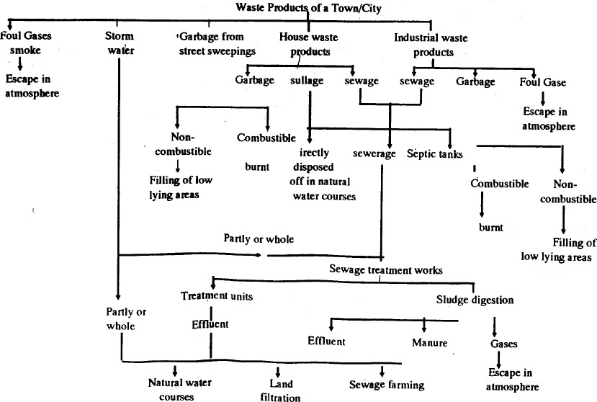

Unit-04/Lecture-02

CLASSIFICATION OF SEWAGE:
- Storm Sewage: Which includes surface runoff developed during and immediately after rainfall over the concerned area.
- Sanitary Sewage: Which includes the liquid wastes of domestic and industrial places. This sewage is extremely foul in nature and required to be disposed of very carefully.

SYSTEMS OF SEWERAGE METHODS:(Waste & sewage disposal):-
1. Conservancy System: = various types of refuse and storm water are collected, conveyed and disposed off separately by different methods - also called dry system-in practice from very ancient times- adopted in small towns, villages and undeveloped portions of large city even it is out of date system.
- Garbage or dry refuse is collected from the dustbins and conveyed by trucks or covered carts once or twice in a day.
- All the uncombustible portions such as sand, dust, clay, ashes etc are used for filling low lying areas and combustible portions such as dry leaves, waste paper, broken furniture etc… are burnt. C)The decaying fruits, vegetables, grass are first dried and then disposed of by burning or in the manufacture of manure.
d)Human excreta or night soil is collected in separate liquid and semi-liquid wastes by animal drawn carts, trucks or tractor trailors and buried in trenches. After 2-3 years the buried night soil is converted into an excellent manure which can be used for growing crops. In this system sullage and storm water are also carried separately in closed or open drains upto the point of disposal, where they are allowed to mix up with streams, rivers or sea.

ADVANTAGES:
- low Initial cost as storm water pass through open drains.
- The quantity of sewage reaching at the treatment plant before disposal is low.
- The sewer section is small and no deposit of silting because storm water goes in open drains.

DISADVANTAGES:
- Possibility of storm water may mix with sewers causing heavy load on treatment plant.
- It is difficult to lay two sewers or construct drains roadside causing inconvenience to the traffic.
- More land is required for human excreta.
- Liquid refuse may get on access in the sub soil and pollute the underground water.
- Aesthetic appearance of city cannot be increased.
- Decomposition of sewage causes insanitary conditions which are dangerous to the public health.
- This system is completely depends sweepers & possibility of spreading of diseases in the town if they are on strike.

2. Water Carriage System: The collection, conveyance and disposal of various type of wastes are carried out with the help of water, used as medium to convey the waste from its point of production to the point of its treatment or final disposal. The excremental matters are mixed up in the large quantity of water and are taken out from the city through properly designed sewerage systems to place of disposel & treatment . The sewage in water carriage system consists of 99.9 percentage of water and 0.1 percentage of solid matters. All the solid matters remain in suspension in the sewage and don’t change the specific gravity of water. So all the hydraulic formulae can be directly used in the design of sewerage system and treatment plants.
MERITS AND DEMERITS OF WATER CARRIAGE SYSTEM: It is the most modern system of drainage, and has the following advantages:
- Hygienes and sanitary aspect : very hygienic since sewage is conveyed through closed conduits , not directly cxposcd to the atmosphere, no bad smell because of continuous flow.
- Epidemic aspect : no chances of outbreak in edpidemic because flies and other insects do not have direct access to the sewage.
- Pollution aspect: The sewage conveyed through the sewers, no chances of the waste water being soaked in the ground thus contaminating the soil. The waste watcr does nor percolate down to join the ground water, wells.
- Cmpactness in design : Since the latrines are flushed after every use, exereta does riot remain and there are no foul smells. The latrines can therefore be attached to the living and bed rooms. This permits a compact design. The lavatories can be accommodated in any part of the house.
- Labour aspect: The labour required for the operation and maintenance is extremely small.
- Land disposal requirements: Because of treatment facilities, the land required for the disposal of the treated wastewater is very much smaller than that required for the conservancy system.
- Cost consideration : Though the initial cost of installation of the system are very high,

DEMERITS
- This system is very costly in initial cost, the running costs are very small since manual labour is very much reduced.
- The maintenance of this system is also costly.
- During monsoon large volume of sewage is to be treated compared to remaining period of year.

 | SW. |  | Conservancy System |  | -- Water Carriage System
 | 1. |  | The system is unhygienic since every thing is visible, |  | The system is hygienic. Sewers are laid below the ground and hence excreta etc. is not visible.
2. |  | Due to putrefication, there is a lot of foul smell, |  | No chances of putrefication, and hence no foul smell
3. |  | Compact house design is not possible |  | Compact design is possible
4. |  | Large labour force is required |  | Labour force is negligibly small
5. |  | Water consumption is small - |  | Requires high water consumption -
6.  , |  | Initial cost is small, though the running costs are high |  | High initial cost. Running costs small
7. |  | No technical persons required |  | Technical persons required for opera tion and maintenance
8. |  | Acute pollution problems — |  | Pollution problems are rare.
9. |  | Risk of spread of epidemic - — |  | No such risk
10. |  | Large land required for the disposal of untreated sewage. |  | Small land required for the disposal of treated sludge
11. |  | Final disposal into streams etc not free from risks |  | Final disposal easier because of treat- ment works.
12. |  | Good quality manure available from the end products |  | The sludge has small manure value. However, treated waste water can be used_for_irrigation_etc. --
13 |  | The system is better suited for rural conditions. |  | The system is better suited for urban conditions.

Unit-04/Lecture-03

TYPES OF SEWERAGE SYSTEM
The sewerage system can be of following three types.
Combined system: here along with domestic sewage, storm’s sewage is carried through the same sewers of sewerage system. In countries like India where actual rainy days are very few, this system will face the problem of maintaining self cleansing velocity in the sewers during dry season, as the sewage discharge may be far lower as compared to the design discharge after including storm water. Advantages
- In an area where rainfall is spread throughout a year, there is no need of flushing of sewers, as self cleansing velocity will developed due to more quantity because of addition of storm water.
- Only one set of pipe will be required for house plumbing.
- In congested areas it is easy to lay only one pipe rather than two pipes as required in other systems.

Disadvantages
- Not suitable for the area with small period of rainfall in a year, because dry weather flow will be small due to which self cleansing velocity may not develop in sewers,resulting in silting.
- Large flow is required to be treated at sewage treatment plant before disposal, hence resulting in higher capital and operating cost of the treatment plant.
- When pumping is required this system is uneconomical.
- During rains overflowing of sewers will spoil public hygiene.

Separate System: Separate conduits are used; one carrying sewage and other carrying storm water run- off which can be directly discharged into the water body since the run-off is not as foul as sewage and no treatment is generally provided. Whereas, the sewage collected from the city is treated adequately before it is discharged into the water body or used for irrigation to meet desired standards. Separate system is advantageous and economical for big towns.

Advantages
- As sewage flows in separate pipe, hence the quantity to be treated at sewage treatment plant is small, resulting in economy of treatment.
- This system may be less costly as only sanitary sewage is transported in closed conduit and storm water can be collected and conveyed through open drains.
- When pumping is required during disposal, this system is economical due to less flow.

Disadvantages
- Self cleansing velocity may not be developed at certain locations in sewers and hence
flushing of sewers may be required.
- This system requires laying two sets of pipe, which may be difficult in congested area.
- This system will require maintenance of two sets of pipelines and hence maintenance cost is more.
Partially separate system: In this system part of the storm water especially collected from roofs and paved courtyards of the buildings is admitted in the same drain along with sewage from residences and institutions, etc. The storm water from the other places is collected separately using separate conduits.

Advantages and disadvantages of partially separate system Advantages
- Economical and reasonable size sewers are required.
- Work of house plumbing is reduced as rain water from roofs, sullage from baths and kitchen, etc. are combined with discharge from water closets.
- Flushing of sewers may not be required as small portion of storm water is allowed to enter in sanitary sewage.

Disadvantages
- Increased cost of pumping as compared to separate system at treatment plants and intermediate pumping station wherever required.
- In dry weather self-cleansing velocity may not develop in the sewers.

CONSIDERATIONS FOR THE SELECTION OF TYPE OF COLLECTION SYSTEM
- The separate system requires laying of two sets of conduits whereas in combined system only one bigger size conduit is required.
- Laying of two separate conduits may be difficult in the congested streets.
- In combined system sewers are liable for silting during non-monsoon season, hence they are required to be laid at steeper gradients. Steeper gradients for the sewers may require more number of pumping stations, particularly for flat terrain, which may make the system costly.
- Large quantity of wastewater is required to be treated before discharge in case of combined system. Hence, large capacity treatment plant is required.
- In separate system, only sewage is treated before it is discharged in to natural water body or used for irrigation. No treatment is generally given to the rainwater collected before it is discharge in to natural water body.
- In case of separate system pumping is only required for sewage. Pumping can be avoided for storm water lines, as they are not very deep and normally laid along the natural slopes. In combined system large capacity pumping station is required to safely handle the flow that is likely to be generated during highest design storm considered.
- Based on site conditions the economy of the system needs to be evaluated and selection is made accordingly.

PATTERNS OF COLLECTION SYSTEM
The network of sewers consists of house sewers discharging the sewage to laterals. The lateral discharges the sewage into branch sewers or sub-mains and sub-mains discharge it into main sewer or trunk sewer. The trunk sewer carries sewage to the common point where adequate treatment is given to the sewage and then it is discharged. The patterns of collection system depend upon:
- The topographical and hydrological features of the area.
- The location and methods of treatment and disposal works.
- The type of sewerage system employed, and
- Extent of area to be served.
Following patterns can be adopted for collection systems as per the suitability (Birdie, 1990).

Perpendicular pattern
- The shortest possible path is maintained for the rains carrying storm water and sewage (Figure 2.1).
- Suitable for separate system and partially separate system.
- This pattern is not suitable for combined system, because treatment plant is required to be installed at many places; otherwise it will pollute the water body where the sewage is discharged.
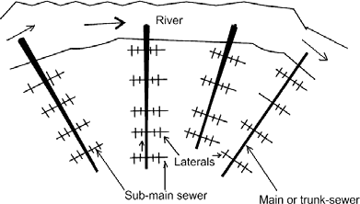
Figure 2: Perpendicular pattern of collection system

Interceptor pattern
- Sewers are intercepted with large size sewers (Figure 2.2).
- Interceptor carries sewage to a common point, where it can be disposed off with or without treatment.
- Overflows should be provided to handle very large flow.

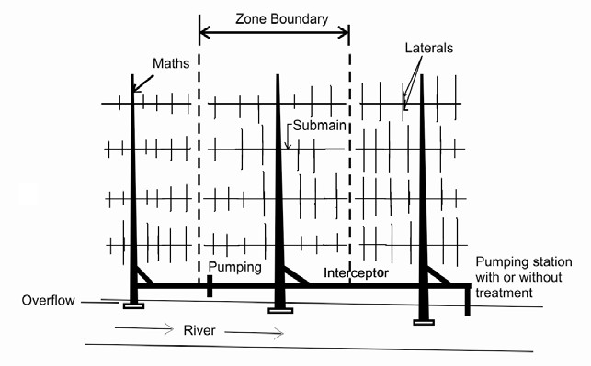

Figure 3: Interceptor pattern of collection system
  - Radial Pattern
- It is suitable for land disposal.
- In this pattern sewers are laid radially outwards from the centre, hence this pattern is called as radial pattern (Figure 2.3).
- The drawback in this pattern is more number of disposal works is required.

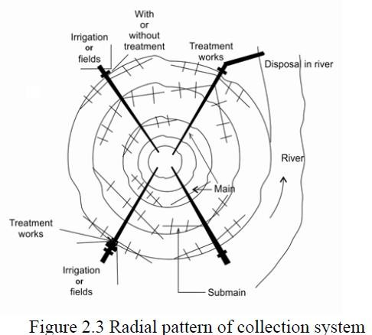

Fan Pattern
- This pattern is suitable for a city situated at one side of the natural water body, such as river.
- The entire sewage flows to a common point where one treatment plant is located (Figure 2.4).
- In this number of converging main sewers and sub-mains are used forming a fan shape.
- Single treatment plant is required in this pattern.
- The drawback in this pattern is that larger diameter sewer is required near to the treatment plant as entire sewage is collected at b common point.
- In addition, with new development of the city the load on existing treatment plant increases. Figure

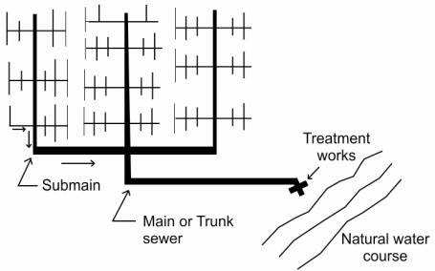

Zone Pattern
- More numbers of interceptors are provided in this pattern (Figure 2.5).
- This pattern is suitable for sloping area than flat areas.

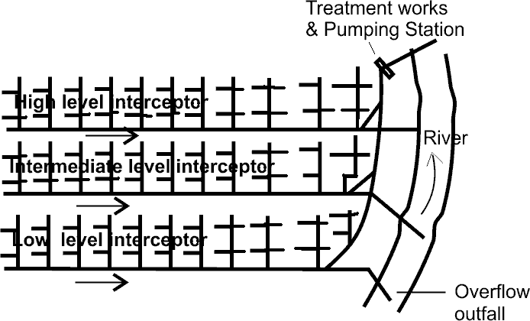

S.NO | RGPV QUESTIONS | Year | Marks

Q.1 | Compare conservancy and water carriage system of sanitation | june2017 | 2
Q.2 | Compare separate and combine sewerage system. | June2016 | 7

Unit-04/Lecture-04

QUANTITY ESTIMATION OF SEWAGE
1.For accurate hydraulic designing the sewer, to avoid inadequate sewer size & economy of the sewerage scheme, provision future years, it is necessary to know the discharge i.e., quantity of sewage, 2 Sources of Sanitary Sewage
1 to domestic sewage,2. industries sewage (wastewater.)3. WW from schools, cinema theaters, hotels, hospitals, and commercial complexes,4 Infiltration of ground water into sewers through leaky joints.
5. Entrance of rainwater in sewer lines through faulty joints or cracks in sewers.

Total Ww Is Devided In To 1) Dry Weather Flow & 2)Storm Water Flow.
- Dry Weather Flow/ Sanitary Sewage :- is the flow that occurs in sewers in separate/ combined sewage system or the the flow occurs during dry seasons when no storm water in sewer, indicates the flow of sanitary sewage, depend upon the rate of water supply, type of area served, economic conditions of the people, weather conditions and infiltration of ground water in the sewers, if sewers are
laid below ground water table.
Dry Weather Flow =1 to domestic sewage,2. industries sewage (wastewater.)3. WW from public facilities like schools, cinema theaters, hotels,hospitals, and commercial complexes,4. Infiltration of ground water into sewers through leaky joints.

FACTORS AFFECTING DRY WEATHER FLOW OR THE QUANTITY OF SANITARY
- Rate of water supply.
- Population growth.
- Type of area served
(d Infiltration of ground water
- Rate of water supply per capita per day as lost in domestic consumption etc- quantity may be assumed to be 80% of the quantity of water supply. The sewers should be designed for a minimum of 150 litres per capita per day.
- Population growth. The sewerage system is designed for the quantity of wastewater not only of the present population but also of the population a few year hence, may be done by the following methods :
1. Arithmetical increase method ,2. Geometrical increase method ,3. Incremental increase method
4. Decreased rate of growth method ,5. Graphical extension method. ,6. Graphical comparison method.
7. Zoning method or master plan method. ,8. Ratio and correlation method. ,9. Growth composition analysis method.
In cities where floor space indcx (FSI) or floor area ratio (FAR) limits are fixed by the municipal authorities, population density may be easily worked out as illustrated below, Lct us assume that a particular development plan rules provide for the lllowing reservations for different land uses : Roads 20%
Gardens 15%
Schools 6%
Markcts 3%
Hospitals and dispensaries 2%
total=46%
.‘. Area available for residential development= 100 — 46 =54% Let us consider an area of 1 hectare (= 10⁴ m²)
:. Actual total floor area residential development
= (0.54x 10⁴)x FSI.
Let us assume FSI of 0.5.
.. Area available for residences = 0.54 x 10⁴ x 0.5= 2700 m² Assuming a floor area requirement of 9 m² per person,
Density ci population,/hectare - = 2700/9=300

Type of area served –DOMESTIC,COMMERCIAL,INDUSTRIAL
(d Infiltration of ground water Evaluation of Sewage Discharge
Apart from accounted water supplied by water authority that will be converted to wastewater,following quantities are considered while estimating the sewage quantity:

Addition due to unaccounted private water supplies
- Addition due to infiltration:- due to groundwater seepage in to sewers through faulty joints or cracks formed in the pipes, depends upon the height of the watertable above the sewer invert level.
- Subtraction due to water losses:-The water loss, through leakage in water distribution system and house connections, does not reach consumers and hence, not appear as sewage.
- Subtraction due to water not entering the sewerage system:- e.g. boiler feed water, water sprinkled over the roads, streets, lawns, and gardens, water consumed in industrial product, water used in air coolers, etc.

Net quantity of sewage:
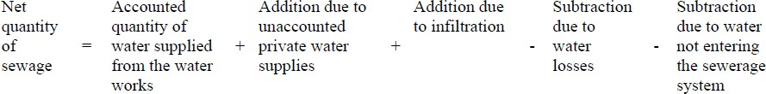

Generally, 75 to 80% of accounted water supplied is considered as quantity of sewage produced.
For estimating design discharge following relation can be considered:
Maximum daily flow = Two times the annual average daily flow (representing seasonal variations) Maximum hourly flow = 1.5 times the maximum daily flow (accounting hourly variations)
= Three times the annual average daily flow
The minimum flow passing through sewers is important to develop self cleansing velocity to avoid silting in sewers. This flow will generate in the sewers during late night hours. The effect of this flow is more pronounced on lateral sewers than the main sewers. Sewers must be checked for minimum velocity as follows:
Minimum daily flow = 2/3 Annual average daily flow
Minimum hourly flow = ½ minimum daily flow
= 1/3 Annual average daily flow
The overall variation between the maximum and minimum flow is more in the laterals and less in the main or trunk sewers. This ratio may be more than 6 for laterals and about 2 to 3 in case of main sewers.

Design Period
The future period for which the provision is made in designing the capacities of the various components of the sewerage scheme is known as the design period depends upon the following:
- Ease and difficulty in expansion,
- Amount and availability of investment,
- Anticipated rate of population growth
- Hydraulic constraints of the systems designed, and
- Life of the material and equipment.
Following design period can be considered for different components of sewage scheme.
- Laterals less than 15 cm diameter : Full development
- Trunk or main sewers : 40 to 50 years
- Treatment Units : 15 to 20 years
- Pumping plant : 5 to 10 years

Design Discharge of Sanitary Sewage:-The total quantity of sewage generated per day is estimated as product of forecasted population at the end of design period considering per capita sewage generation and appropriate peak factor. The per capita sewage generation can be considered as 75 to 80% of the per capita water supplied per day. The increase in water demand due to population increase ,to increase in living standards.

Unit-04/Lecture-05

QUANTITY ESTIMATION OF STORM WATER
Factors Affecting the Quantity of Storm Water:-The surface run-off resulting after precipitation contributes to the storm water quantity , is very large as compared with sanitary sewage & The factors affecting are as below:
i.) Area of the catchment ,ii.) Slope and shape of the catchment area,iii) Porosity of the soil, iv.)obstruction in the flow of water as trees, fields, gardens, etc.,v.)Initial state of catchment area with respect to wetness.,vi) Intensity and duration of rainfall,vii.)Atmospheric temperature and humidity viii.)Number and size of ditches present in the area
Measurement of Rainfall:-The rainfall intensity(usually expressed as mm/hour or cm/hour.) could be measured by using rain gauges and recording the amount of rain falling in unit time by the
rain gauges by manual recording type or automatic recording rain gauges.

Methods for Estimation of Quantity of Storm Water
- Rational Method
- Empirical formulae method
In both the above methods, the quantity of storm water is considered as function of intensity of rainfall and coefficient of runoff.
Time of Concentration: The period after which the entire catchment area will start contributing to the runoff is called as the time of concentration.
- The rainfall with duration lesser than the time of concentration will not produce maximum discharge.
- The runoff may not be maximum, even when the duration of the rain is more than the time of concentration. This is because in such case the intensity of rain reduces with the increase in its duration.
- The runoff will be maximum, when the duration of rainfall is equal to the time of concentration and is called as critical rainfall duration. The time of concentration is equal to sum of inlet time and time of travel.

Time of concentration = Inlet time + time of travel
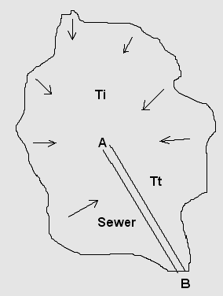
Figure 5: Runoff from a given catchment

Inlet Time: The time required for the rain in falling on the most remote point of the tributary area to flow across the ground surface along the natural drains or gutters up to inlet of sewer is called inlet time (Figure 6.1). The inlet time ‘Ti’ can be estimated using relationships similar to following. This coefficients will have different values for different catchments.
Ti = [ 0.885 L³/H]^{0.385}
Where,
Ti = Time of inlet, time
L = Length of overland flow in Kilometer from critical point to mouth of drain H = Total fall of level from the critical point to mouth of drain, meter
Time of Travel: The time required by the water to flow in the drain channel from the mouth to the point under consideration or the point of concentration is called as time of travel.
Time of Travel (Tt) = Length of drain/ velocity in drain
Runoff Coefficient: The total precipitation falling on any area is dispersed as percolation, evaporation, storage in ponds or reservoir and surface runoff. The runoff coefficient can be defined as a fraction, which is multiplied with the quantity of total rainfall to determine the quantity of rain water, which will reach the sewers. The runoff coefficient depends upon the porosity of soil cover, wetness and ground cover. The overall runoff coefficient for the catchment area can be worked out as follows:
Overall runoff coefficient, C = [A1.C1 + A2.C2 + ….+ An.Cn] / [ A1 + A2 + …+ An]
Where, A1, A2, …. are types of area with C1, C2, …. as their coefficient of runoff, respectively. The typical runoff coefficient for the different ground cover is provided in the Table 6.1.
Table 6.1 Runoff coefficient for different type of cover in catchment
Type of Cover Coefficient of runoff
Business areas | 0.70 – 0.90
Apartment areas | 0.50 – 0.70
Single family area | 0.30 – 0.50
Parks, Playgrounds, Lawns | 0.10 – 0.25
Paved Streets | 0.80 –0.90
Water tight roofs | 0.70 – 0.95

Rational method
Storm water quantity can be estimated by rational method as below:
Storm water quantity, Q = C.I.A / 360 Where,
Q = Quantity of storm water, m³/sec C = Coefficient of runoff
I = intensity of rainfall, mm/hour, and A = Drainage area in hectares
OR
Q = 0.278 C.I.A
Where, Q is m³/sec; I is mm/hour, and A is area in square kilometer
Empirical FormulaeEmpirical formulae are used for determination of runoff from very large area. Variousempirical relationships are developed based on the past observations on specific site conditions suiting a particular region. These empirical formulae can be used for prediction of storm water
runoff for that particular catchment. A] Burkli – Zeiglar formula
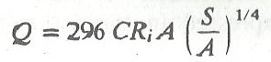
B] Mc Math formula (used in USA)
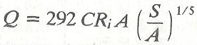
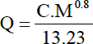
C] Fuller’s formula
(Where, S- Slope of the are, M- drainage area in sq. km., A – drainage area in hect.)

Empirical formulae for rainfall intensities
These relationships between rainfall intensity and duration are developed based on long experience in field (Figure 6.2). Under Indian conditions, intensity of rainfall in design is usually in the range 12 mm/h to 20 mm/h. In general, the empirical relationship has the
following forms:
I = a/ (t + b) OR I = b / tn Where, a, b, and n are constants.
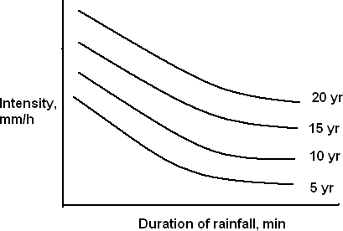
Figure 6.2 Relationship of rainfall duration and intensity

British Ministry of Health formula
I = 760 / (t + 10) (for storm duration of 5 to 20 minutes)
I = 1020 / (t + 10) (for storm duration of 20 to 100 minutes)
Where, I is intensity of rainfall, mm/h and t is duration of storm, minutes.
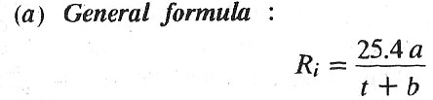
where Ri = rainfall intensity in mm/hour.
t = duration of storm in minutes≈time of concentration. a , b = constants.
The United States Ministry of Health recommend the following values of constants a and b
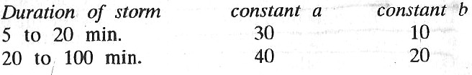
6.4 Examples
1. Determine designed discharge for a combined system serving population of 50000 with rate of water supply of 135 LPCD. The catchment area is 100 hectares and the average coefficient of runoff is 0.60. The time of concentration for the design rainfall is 30 min and the relation between intensity of rainfall and duration is I = 1000/(t + 20).

Solution
Estimation of sewage quantity
Considering 80% of the water supplied will result in wastewater generation,
the quantity of sanitary sewage = 50000 x 135 x 0.80 = 5400 m³/day = 0.0625 m³/sec Considering peak factor of 2.5, the design discharge for sanitary sewage = 0.0625 x 2.5
= 0.156 m³/sec
Estimation of storm water discharge Intensity of rainfall, I = 1000/(t + 20) Therefore, I = 1000/(30 + 20) = 20 mm/h Hence, storm water runoff, Q = C.I.A/360
= 0.6 x 20 x 100/(360) = 3.33 m³/sec
Therefore, design discharge for combined sewer = 3.33 + 0.156 = 3.49 m³/sec
Example 2. The catchment area is of 300 hectares. The surface cover in the catchment can be classified as given below:
Type of cover | Coefficient | of runoff | Percentage
Roofs | 0.90 |  | 15
Pavements and yards | 0.80 |  | 15
Lawns and gardens | 0.15 |  | 25
Roads | 0.40 |  | 20
Open ground | 0.10 |  | 15
Single family dwelling | 0.50 |  | 10
Calculate the runoff coefficient and quantity of storm water runoff, if intensity of rainfall is
30 mm/h for rain with duration equal to time of concentration. If population density in the area is 350 persons per hectare and rate of water supply is 200 LPCD, calculate design discharge for separate system, partially separate system, and combined system.

Solution
Estimation of storm water discharge for storm water drain of separate system
Overall runoff coefficient C = [A1.C1 + A2.C2 + ….+ An.Cn] / [ A1 + A2 + …+ An]
= (0.15 x 0.90 + 0.15 x 0.80 + 0.25 x 0.15 + 0.20 x 0.4 + 0.15 x 0.1 + 0.10 x 0.5)
0.15 + 0.15 + 0.25 + 0.20 + 0.15 + 0.10
= 0.44
Therefore quantity of storm water, Q = C.I.A/360
= 0.44 x 30 x 300/360
= 11 m3/sec
Estimation of sewage discharge for separate system sanitary sewer
Quantity of sanitary sewage = 300 x 350 x 200 x 0.80 = 16800 m3/day = 0.194 m3/sec Considering peak factor of 2, the design discharge for sanitary sewers = 0.194 x 2
= 0.389 m3/sec
Estimation of discharge for partially separate system
Storm water discharge falling on roofs and paved courtyards will be added to the sanitary sewer. This quantity can be estimated as:
Average coefficient of runoff = (0.90 x 45 + 0.80 x 45) / 90 = 0.85
Discharge = 0.85 x 30 x 90 / 360 = 6.375 m3/sec
Therefore total discharge in the sanitary sewer of partially separate system = 6.375 +0.389 = 6.764 m3/sec and the discharge in storm water drains = 11 – 6.375 = 4.625m3/sec.
Unit-04/Lecture-06

HYDRAULIC DESIGN OF SEWERS AND STORM WATER DRAINS
General Consideration:-
- Sewers are laid at steeper gradients falling towards the outfall point with circular pipe cross section.
- Sewers are designed to carry the maximum quantity of sanitary sewage .

Requirements of Design and Planning of Sewerage system
The sewerage scheme is designed to remove entire sewage effectively and efficiently from the houses to the point of disposal. Following aspects should be considered while designing the system.
- The sewers provided should be adequate in size to avoid overflow and possible health hazards.
- For evaluating proper diameter of the sewer, correct estimation of sewage discharge is necessary.
- The flow velocity inside the sewer should neither be so large as to require heavy excavation and high lift pumping, nor should be so small causing deposition of the solid in the sewers.
- The sewers should be laid at least 2 to 3 m deep to carry sewage from basement.
- The sewage should flow under gravity with 0.5 to 0.8 full at designed discharge, i.e. at the maximum estimated discharge.
- The sewage is conveyed to the point usually located at low-lying area, where the treatment plant is located.
- Treatment plant should be designed taking into consideration the quality of raw sewage expected and to meet the discharge standards.

Provision of Freeboard in Sewers:-
Sanitary Sewers:-Sewers with diameter less than 0.4 m are designed to run half full at maximum discharge, and sewers with diameter greater than 0.4 m are designed 2/3 to ¾ full at maximum discharge. The extra space provided in the sewers provides factor of safety to counteract against the following factors:
- Safeguard against lower estimation of the quantity of wastewater to be collected at the end of design period due to private water supply by industries and public. Thus, to ensure that sewers will never flow full eliminating pressure flow inside the sewer.
- Large scale infiltration of storm water through wrong or illegal connection, through underground cracks or open joints in the sewers.
- Unforeseen increase in population or water consumption , consequent increase in sewage production.

7.4.2 Storm Water Drains
Storm water drains are provided with nominal freeboard, above their designed full supply line because the overflow from storm water drains is not much harmful. Minimum of 0.3 m free board is generally provided in storm water drains.

7.5 Hydraulic Formulae for Determining Flow Velocities
Following formulae can be used for design of sewers.

Manning’s Formula
This is most commonly used for design of sewers. The velocity of flow through sewers can be determined using Manning’s formula as below:
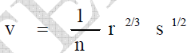
Where,
v = velocity of flow in the sewer, m/sec
r = Hydraulic mean depth of flow, m= a/p a = Cross section area of flow, m²
p = Wetted perimeter, m
n = Rugosity coefficient, depends upon the type of the channel surface i.e., material and lies between 0.011 to 0.015. For brick sewer it could be 0.017 and 0.03 for stone
facing sewers.
s = Hydraulic gradient, equal to invert slope for uniform flows.
- Chezy’s Formula= v = C r^{1/2}s^{1/2}
Where, C is Chezy’s constant and remaining variable same as above equation.

Crimp and Burge’s Formula
v = 83.5 r^{2/3}s^{1/2}

Hazen- Williams Formula
V = 0.849 C R^{0.63} S^{0.54}
Minimum Velocity: Self Cleansing Velocity:-The velocity that would not permit the solids to settle down and even scour the deposited particles of a given size is called as self-cleansing velocity , should at least develop once in a day so as not to allow any deposition in the sewers. Otherwise, if such deposition takes place, it will obstruct free flow causing further deposition and finally leading to the complete blocking of the sewers. This minimum velocity or self-cleansing velocity can be worked out as below:
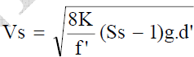
Where,
K= constant, for clean inorganic solids = 0.04 and for organic solids = 0.06 f' = Darcy Weisbach friction factor (for sewers = 0.03)
Ss = Specific gravity of sediments g = gravity acceleration
d' = diameter of grain, m
- Hence, for removing the impurities present in sewage i.e., sand up to 1 mm diameter with specific gravity 2.65 and organic particles up to 5 mm diameter with specific gravity of
1.2, it is necessary that a minimum velocity of about 0.45 m/sec and an average velocity of about 0.9 m/sec should be developed in sewers.
- Hence, while finalizing the sizes and gradients of the sewers, they must be checked for the minimum velocity that would be generated at minimum discharge, i.e., about 1/3 of the average discharge.
- While designing the sewers the flow velocity at full depth is generally kept at about 0.8 m/sec or so. Since, sewers are generally designed for ½ to ¾ full, the velocity at ‘designed discharge’ (i.e., ½ to ¾ full) will even be more than 0.8 m/sec. Thus, the minimum velocity generated in sewers will help in following ways:
- Adequate transportation of suspended solids,
- Keeping the sewer size under control; and
- Preventing the sewage from decomposition by moving it faster, & preventing evolution of foul gases. Maximum Velocity or Non-scouring Velocity:-The interior surface of the sewer pipe gets scored due to the continuous abrasion caused by suspended solids present in sewage, is pronounced at higher velocity than what can be tolerated by the pipe materials, will reduce the life span of the pipe and their carrying capacity. In order to avoid this, it is necessary to limit the maximum velocity that will be produced in sewer pipe at any time. This limiting or nonscouring velocity mainly depends upon the material of sewer. The limiting velocity for different sewer material is provided in Table 7.2.
Table 7.2 Limiting or non-scouring velocity for different sewer material.
 | Sewer Material |  | Limiting velocity, m/sec
 | Vitrified tiles |  | 4.5 – 5.5
 | Cast iron sewer |  | 3.5 – 4.5
 | Cement concrete |  | 2.5 – 3.0
 | Stone ware sewer |  | 3.0 – 4.5
 | Brick lined sewer |  | 1.5 – 2.5

Effect of Flow Variations on Velocities in a Sewer
The discharge flowing through sewers varies considerably from time to time. Hence, there occur variation in depth of flow and thus, variation in Hydraulic Mean Depth (H.M.D.). Due to change
in H.M.D. there occur changes in flow velocity, because it is proportional to (H.M.D.)^{2/3}. Therefore, it is necessary to check the sewer for minimum velocity of about 0.45 m/sec at the time of minimum flow (1/3 of average flow) and the velocity of about 0.9 to 1.2 m/sec should be developed at a time of average flow. The velocity should also be checked for limiting velocity

i.e. non-scouring velocity at the maximum discharge.
For flat ground sewers are designed for self-cleansing velocity at maximum discharge. This will permit flatter gradient for sewers. For mild slopping ground, the condition of developing selfcleansing velocity at average flow may be economical. Whereas, in hilly areas, sewers can be
designed for self-cleansing velocity at minimum discharge, but the design must be checked for non-scouring velocity at maximum discharge.

Example: 1
Design a sewer for a maximum discharge of 650 L/s running half full. Consider Manning’s rugosity coefficient of n = 0.012, and gradient of sewer S = 0.0001.

Solution
Q = A.V
0.65 = (πD²/8) (1/n) R^{2/3} S^{1/2} R = A/P
Solving for half full sewer, R = D/4
Substituting in above equation and solving we get D = 1.82 m.
Comments: If the pipe is partially full it is not easy to solve this equation and it is time consuming.

Unit-04/Lecture-07
HYDRAULIC ELEMENTS OF CIRCULAR SEWERS

Sewers of circular cross-section are more commonly used. How ever ‘egg-shaped’ sewers arc also used .Circular sewers offer the following advantages :
1. easily manufactured. 2. gives the maximum area for a given perimeter, and thus gives the greatest H.M.D. when running full or half full. It is therefore the most efficient section at these flow conditions. 3. most economical section since it utilizes minimum quantities of the material. 4.has uniform curvature all round, and hence it offers less opportunities for deposits.
A circular sewer may run either full or partially full. However the advantage at S.N. 2 above is obtained when the sewer runs atleast half-full. This advantage is lost if the depth of flow becomes less than half full, since both the velocity as well as discharge reduce considerably with the reduction in the depth of flow. (a) Circular section running full. Let D be the internal diameter of circular sewer.
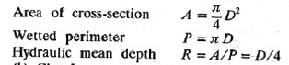
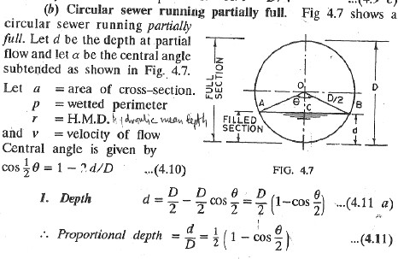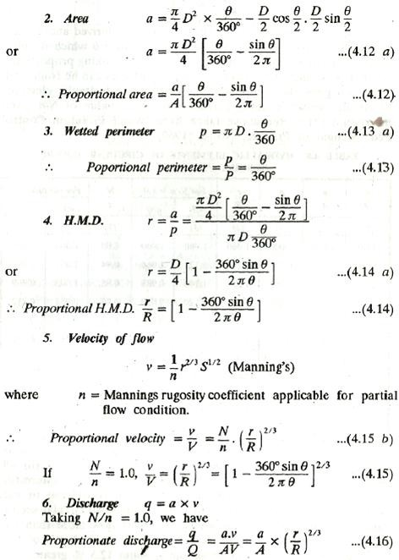

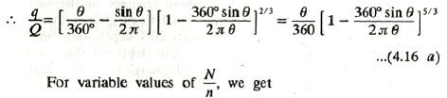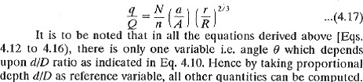

Hydraulic Characteristics of Circular Sewer Running Full or Partially Full
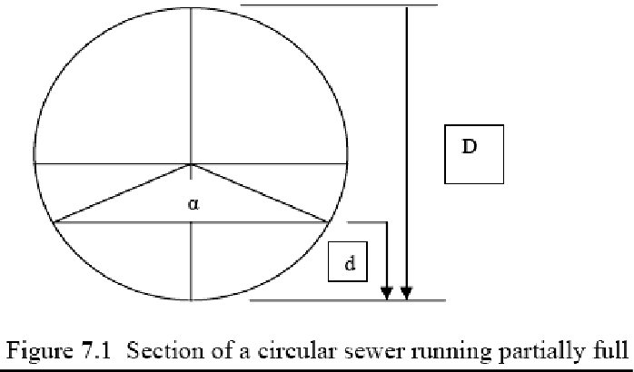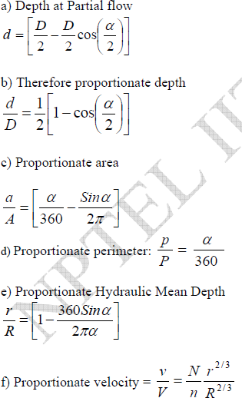

Unit-04/Lecture-07
NUMERICALS
Example: 12
A 300 mm diameter sewer is to flow at 0.3 depth on a grade ensuring a degree of self cleansing equivalent to that obtained at full depth at a velocity of 0.9 m/sec. Find the required grade and associated velocity and rate of discharge at this depth. Assume Manning’s rugosity coefficient n
= 0.013. The variation of n with depth may be neglected.

Solution:
Manning’s formula for partial depth v = 1/n x r ^{2/3} s ^{½}
for full depth V = 1/N x R ^{2/3} S ^{½}
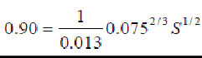
Using V = 0.90 m/sec, N = n = 0.013 and R = D/4 = 75 mm = 0.075 m S = 0.0043 This is the gradient required for full depth.
and, Q = A.V = π/4 (0.3)² x 0.90 = 0.064 m³/s
At depth d = 0.3D, (i.e., for d/D = 0.3) we have a/A = 0.252 and r/R = 0.684 (neglecting variation of n)
Now for the sewer to be same self cleansing at 0.3 m depth as it will be at full depth, we have the gradient (ss) required as ss = (R/r)S
Therefore, ss = S / 0.684
= 0.0043 / 0.0684 = 0.0063
Now, the velocity vs generated at this gradient is given by
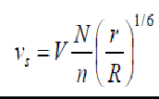
= 1 x (0.684)1/6 x 0.9
= 0.846 m/s
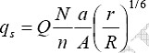
The discharge qs is given by
qs = 1 x (0.258) x (0.939) x (0.064)
= 0.015 m³/s.

Example: 2
A combined sewer was designed to serve an area of 60 sq. km with an average population density of 185 persons/hectare. The average rate of sewage flow is 350 L/Capita/day. The maximum flow is 50% in excess of the average sewage flow. The rainfall equivalent of 12 mm in 24 hr can be considered for design, all of which is contributing to surface runoff. What will be the discharge in the sewer in m3/Sec? Find the diameter of the sewer if running full at maximum discharge.

Solution:
Total population of the area = population density x area
= 185 x 60 x 10²
= 1110 x 10³ persons
Average sewage flow = 350 x 11.1 x 10⁵ Liters/day
= 388.5 x 10⁶ L/day
= 4.5 m³/sec
Storm water flow = 60 x 10⁶ x (12/1000) x [1/(24 x 60 x 60)]
= 8.33 m³/sec
Maximum sewage flow = 1.5 x average sewage flow
= 1.5 x 4.5 = 6.75 m³/sec
Total flow of the combined sewer = sewage flow + storm flow
= 6.75 + 8.33 = 15.08 m³/sec
Hence, the capacity of the sewer = 15.08 m³/sec

Example: 3
Find the minimum velocity and gradient required to transport coarse sand through a sewer of 40 cm diameter with sand particles of 1.0 mm diameter and specific gravity 2.65, and organic matter of 5 mm average size with specific gravity 1.2. The friction factor for the sewer material may be assumed 0.03 and roughness coefficient of 0.012. Consider k = 0.04 for inorganic and 0.06 for organic solids.
Minimum velocity i.e. self cleansing velocity
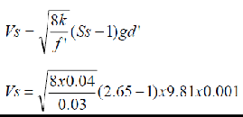
= 0.4155 m/sec say 0.42 m/sec
Similarly, for organic solids this velocity will be 0.396 m/sec Therefore, the minimum velocity in sewer = 0.42 m/sec Now, Diameter of the sewer D = 0.4 m
Hydraulic Mean Depth = D/4 = 0.4/4 = 0.1 m Using Manning’s formula:
V = 1/n R^{2/3} S^{1/2}
0.42 = (1/0.012) x (0.1)^{2/3} x S^{1/2}
S = 1/1824.5
Therefore, gradient of the sewer required is 1 in 1824.5.

Example : 4
Design a sewer running 0.7 times full at maximum discharge for a town provided with the separate system, serving a population 80,000 persons. The water supplied from the water works to the town is at a rate of 190 LPCD. The manning’s n = 0.013 for the pipe material and permissible slope is 1 in 600. Variation of n with depth may be neglected. Check for minimum and maximum velocity assuming minimum flow 1/3 of average flow and maximum flow as 3 times the average. (for d/D = 0.7, q/Q = 0.838, v/V = 1.12)

Solution
Average water supplied = 80000 x 190 x (1/24 x 60 x 60 x 1000) = 0.176 m3/sec
Sewage production per day, (considering 80% of water supply) = 0.176 x 0.8 = 0.14 m3/sec Maximum sewage discharge = 3 x 0.14 = 0.42 m3/sec
Now for d/D = 0.7, q/Q = 0.838, v/V = 1.12 Therefore, Q = 0.42/0.838 = 0.5 m³/sec Now
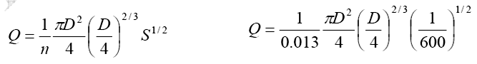
Therefore, D = 0.78 V = Q/A = 1.04 m/sec Now, v/V = 1.12
Therefore v = 1.12 x 1.04 = 1.17 m/sec
This velocity is less than limiting velocity hence, OK
Check for minimum velocity
Now qmin = 0.14/3 = 0.047 m³/sec qmin/Q = 0.047/0.5 = 0.09
For q/Q = 0.09, d/D = 0.23 and v/V = 0.65
Therefore, the velocity at minimum flow = 0.65 x 1.04 = 0.68 m/sec This velocity is greater than self cleansing velocity, hence OK
dmin = 0.23 x 0.78 = 0.18 m
Comment: If the velocity at minimum flow is not satisfactory, increase the slope or try with reduction in depth of flow at maximum discharge or reduction in diameter of the sewer.

Unit-04/Lecture-08

Sewer: Types,Shapes, Hydraulic Design (Capacity, Size, Grade, etc.)
Sewerage are closed conducts are called sewers and are laid under ground for conveying foul discharges from water-closets of public and domestic buildings, chemical mixed water from industries without creating any nuisance outside the town. Sewers should have such cross-section that self-cleaning velocity should be developed even during dry weather flow. No deposit should
settle down in the bed of sewers under any circumstances. These should be laid in the town at such a slope that water in case of flood in river at the outlet should not come out from manholes and cause insanitary conditions.
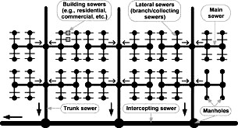

Types of Sewers
- Sanitary Sewer
It carries sanitary sewage i.e, wastewater from municipality including domestic and industrial wastewater.

Storm Sewer
It carries storm sewage including surface runoff and street wash.

Combined Sewer
It carries domestic, industrial and storm sewage.

House Sewer
It is the sewer conveying sewage from plumbing system of a building to common/municipal sewer.

Lateral Sewer
This sewer carries discharge from house sewers.

Submain Sewer
This sewer receives discharge from two or more laterals.

Main/Trunk Sewer
It receives discharge from two or more submains.

Outfall Sewer
It receives discharge from all collecting system and conveys it to point of final disposal. DIFFERENT SHAPES OF CROSS-SECTIONS FOR SEWERS CIRCULAR AND NON CIRCULAR
Generally the sewers of circular shape are adopted because of following facts
- least perimeter and hence construction cost is minimum for the same area of other shape
- Deposition of organic matter are reduced to minimum because of no corners
- easy to manufacture or construct and handle
- Being circular shape, these are subjected to hoop compression hence the concrete required is minimum and no reinforcement is required
- They posses excellent hydraulic properties because they provide the maximum hydraulic mean depth when running full or half full.
The circular sewers prove to be best when the discharge doesnot vary too much and the chances of sewers running with very low depths (less than half) are less.
However the sewers of non-circular shapes are also used for the following reasons
- To bring down the cost of construction
- to improve the velocity of flow when the depth of sewage is low
- to secure more structural strength
- to simplify the process of construction
- to make them large enough for a man to enter for cleaning or repairing.

SHAPES OF NON-CIRCULAR SHAPES:
The following are the non-circular shapes, which are commonly,used for sewers.
1. BASKET HANDLE SECTION: In this type of sewer, the upper portion of sewer has got the shape of a basket-handle as shown in fig. 3.1. The bottom portion is narrower and carries small
discharges during mansoon and combined sewage is carried through the full section. This shape of sewer is not generally used at present.
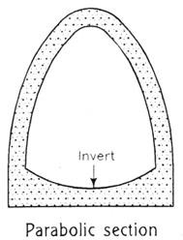
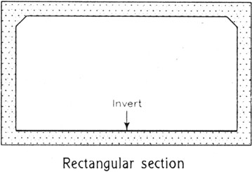
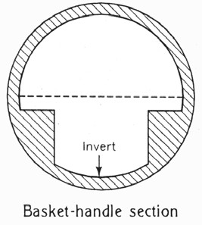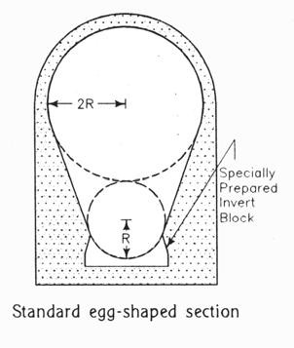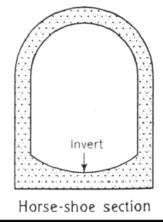
EGG-SHAPED OR OVOID SECTION: This type of sewer is suitable for carrying combined flow. The main advantage of this type of sewer is that it gives slightly higher velocity during low flow than a circular sewer of the same capacity. But construction of this section is difficult and less stable than circular section. Inverted egg-shaped sewer gives better stability and carries heavy
discharges. . The principal advantage is slightly higher velocity for low flows over the circular sewer of eqal çapacity.
Disadvantages : (1.) Some what unstable because the small end of the egg is down and it has to support the weight of the upper broader section. (2.)Difficult to Construct. (3.)Expensive, as more material is required and as the cost of construction is also high. (4.) In the absence of adequate gradient, it. is not self-cleansing. Egg-shaped sewers were formerly used more than at present. Because of the disadvantages mentioned above, these arc becoming obsolete these days.
There are several forms of egg-shaped or ovoid sewers, but the following two forms are very common (Fig. 4.10)
(I) Standard or metropolitan Section.
(ii) New shaped section.
The details are as shown in fig .
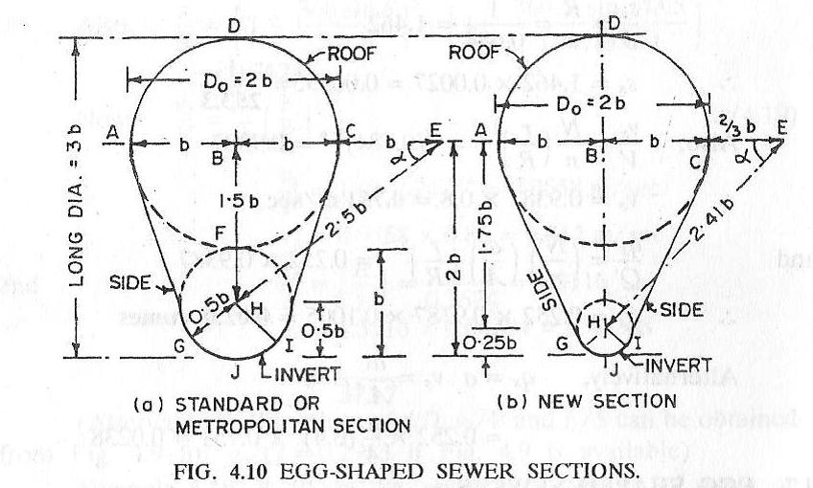
HORSE-SHOE SECTION: This type of sewers are used for the construction in tunnel to carry heavy discharges, such as truck and outfall sewers. This is also suitable when the available
headroom for the construction of sewer is limited. The invert of the sewer may be flat, circular or paraboloid and top is semicircular with sides vertical or inclined as shown in fig above.
PARABOLIC SECTION: This type of sewers are suitable for carrying comparatively small quantities of sewage and economical in construction. The invert of sewer may be flat or
parabolic and upper arch of the sewer takes the form of parabola as shown in fig above. RECTANGULAR OR BOX TYPE SECTION: The rectangular or box type section of sewer is stable and it is easy to construct as shown in fig above. It is some times used to work as a storage tank during the tide it becomes necessary to store the sewage for some period.
SEMI-CIRCULAR: This type of sewers are suitable for constructing large sewers with less available headroom and it posses better hydraulic properties as shown in figure below.
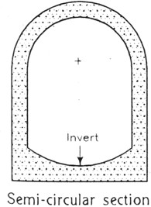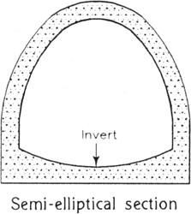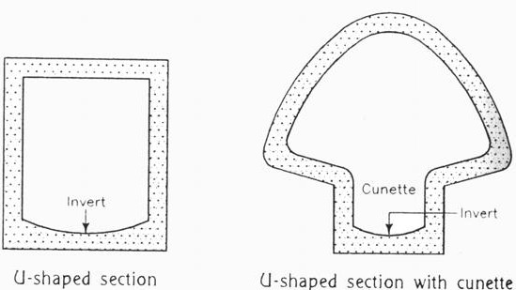
SEMI-ELLIPTICAL SECTION: This type of the section is suitable to carry heavy discharges and adopted for soft soil, as it is more stable. The dia of sewer may be more than 1.8m and
posses good hydraulic properties except at low depths as shown in fig above.
U-SHAPED SECTION: The shape of this section is the true shape of letter as shown in fig. Or small trench of U shape can be setup in the larger section of sewer as shown in fig above. The
trench is known as the cunette and adopted for a combined sewer having predominant flow of storm water.

CHOICE OF TYPES OF SEWERS
The following factors are to be carefully considered while making selection for the materials of sewer.
1. Cost: 2. Durability: 3. Imperviousness: 4. Resistance to Abrasion: 5. Resistance to corrosion: 6.

Weight:

Unit-04/Lecture-09

Sewer Appurtenances
The structures, which are constructed at suitable intervals along the sewerage system to help its efficient operation and maintenance, are called as sewer appurtenances. These include:
(1) Manholes, (2) Drop manholes, (3) Lamp holes, (4) Clean-outs, (5) Street inlets called Gullies, (6) Catch basins, (7) Flushing Tanks, (8) Grease & Oil traps, (9) Inverted Siphons, and (10) Storm Regulators.
Man-holes: Man holes are the openings of either circular or rectangular in shape constructed on the alignment of a sewer line to enable a person to enter the sewer for inspection, cleaning and flushing. They serve as ventilators for sewers, by the provisions of perforated man-hole covers. Also they facilitate the laying of sewer lines in convenient length.
Man-holes are provided at all junctions of two or more sewers, whenever diameter of sewer changes, whenever direction of sewer line changes and when sewers of different elevations join together.

LOCATION:
Manholes are provided at every change of alignment, gradient or diameter of the sewer.

FUNCTION:
Manholes are provided for inspection, cleaning, repairs and maintenance of the sewer.
CONSTRUCTION:A Manhole consists of a) Working chamber,b) An access shaft and
- A strong cover on the top flush with the road level.
- WORKING CHAMBER: has such a size, so that necessary examination and cleaning can be done easily. The minimum internal size of the chamber are as follows.
- For depth of 0.8m or less 0.75m x 0.75m
- For depth between 0.8m and 2.1m 1.2m x 0.9m
- For depth more than 2.1m 1.2m x 0.9m or 1.4dia circular chamber.

ACCESS SHAFT:
The access shaft provides an access to the working chamber. The shaft is formed, by corbelling the working chamber on three as shown in fig no. 4.1. So that the cover frame can be fitted in the opening, the minimum internal dimensions of the access shaft are 0.5 x 0.5m

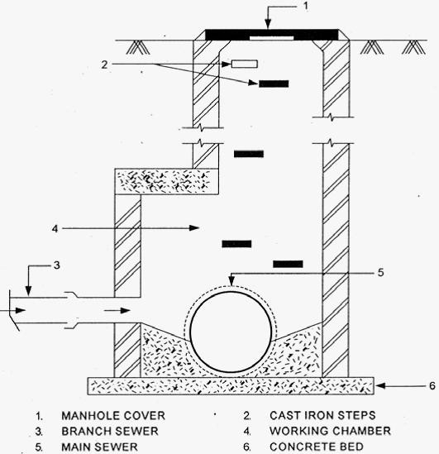
COVER:At the top of manhole, the manhole cover of cast iron or R.C.C is provided to cover the opening depending upon the type of traffic on the road with flushing the road level.
INSIDE M.H.:-The bottom of the manhole is usually made of concrete slightly sloped at the top towards the open channels, which are in continuation of the sewer line. The channels are sometimes lined with half-round sewer pipe section. The top surface of the concrete is called benching and the man stands on its top during cleaning and inspection of the sewerlines over the cement concrete walls not less than 20cm thickness are constructed. Circular shape is structurally more stable and stronger though it is difficult in construction. The maximum distance between two manholes should be 30m and the distance between the manhole and gully chambers should not exceed 6m.

Special Man-holes:
Junction chambers: Man-hole constructed at the intersection of two large sewers.
Drop man-hole: When the difference in elevation of the invert levels of the incoming and outgoing sewers of the man-hole is more than 60 cm & and there is sufficient roof within the working
chamber, the connecting pipe may be directly brought through the manhole wall by providing a ramp in benching. Such manholes which drop the level of invert of the incoming sewer, by providing a vertical shaft are called drop manholes.
The main purpose being to avoid the splashing of sewage on the man working and on the masonary work. The branch sewer line is connected to the manhole in such a way that it can be cleaned and rodded when necessary. For inspection of the incoming sewage and cleaning of vertical shaft, the vertical shaft is taken upto the ground level as shown in fig.

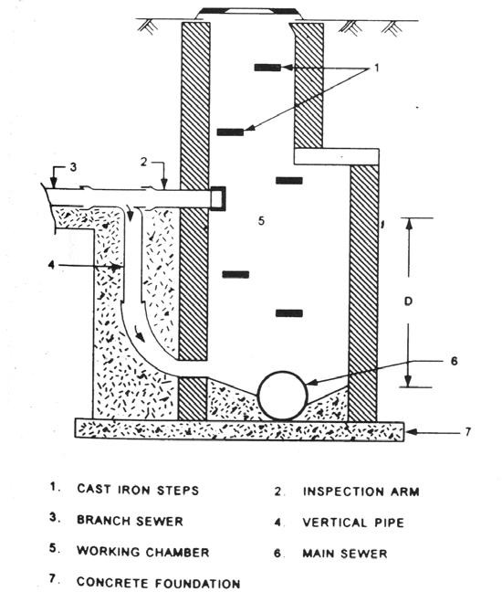

Flushing man-holes: They are located at the head of a sewer to flush out the deposits in the sewer with water.
Lamp-holes: Lamp holes are the openings constructed on the straight sewer lines between two man- holes which are far apart and permit the insertion of a lamp into the sewer to find out obstructions if any inside the sewers from the next man-hole.
Street inlets: Street inlets or gullies are the openings in the street a or b or gutter to collect the storm water and surface wash flowing along the street and convey it to storm or combined sewer by means of stoneware pipes of 25 to 30cm diameter. Fig below shows the most useful location of street inlet at the
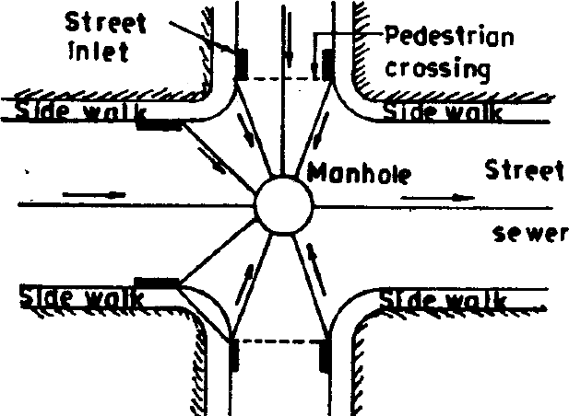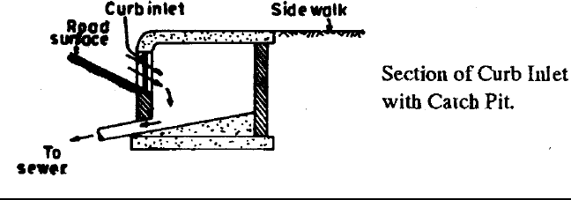street junction in such way that the storm water may not flow across any of the streets or flood the cross walks causing interference with the traffic street inlets are of three types.
- CURB INLET: In which an opening is provided in the road curb for the entrance of storm water. The gutter opening bars are provided to prevent the passage of dry-leaves, papers etc in the
sewer line as shown in fig above.
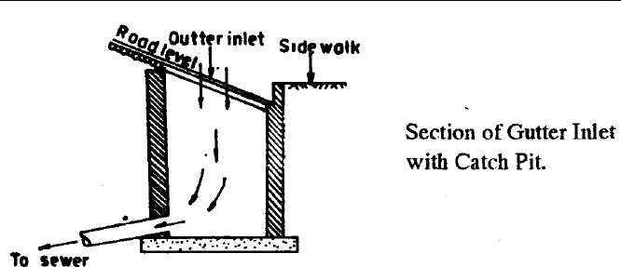
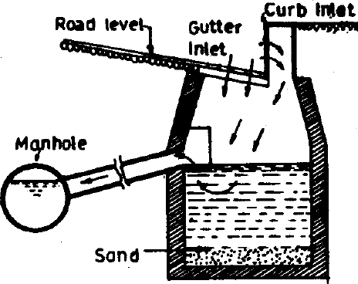
- GUTTER INLET: These are placed directly below the road gutter and storm water directly enters them from the top. Such inlets catch very large volume of water and are most suitable in roads having steep slopes. These inlets are provided with cast Iron gratings at their top to prevent floating matters entering the sewer. The top grating should be sufficiently strong the bear the traffic loads. The main difficulty with such inlets is that of the heavy cost and these are mostly stolen and the pit remain uncovered as shown in fig below.
- COMBINED GUTTER AND CURB INLET: These inlets in which the storm water enters from both the gutter and curb as shown in fig above.
storm water overflows:- These are used for preventing overloading of sewers, pumping stations, treatment plants or disposal arrangement, by diverting the excess flow to relief sewer. The overflow device may be side flow or leaping weirs according to the position of the weir, siphon spillways or float actuated gates and valves.
1 Side Flow Weir:-It is constructed along one or both sides of the combined sewer and delivers the excess flow during storm period to relief sewers or natural drainage courses (Figure 8.9). The crest of the weir is set at an elevation corresponding to the desired depth of flow in the sewer. The weir
length must be sufficient long for effective regulation of the flow.
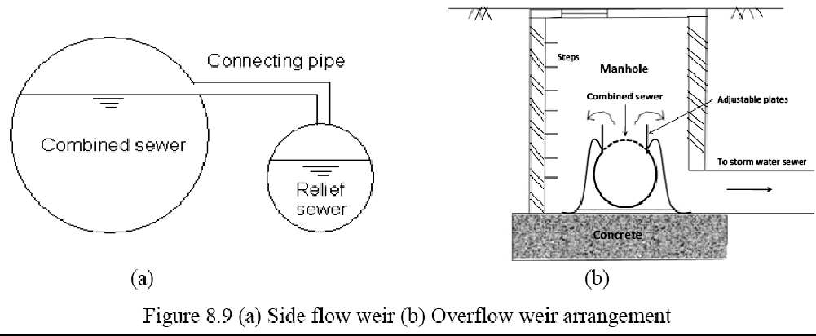

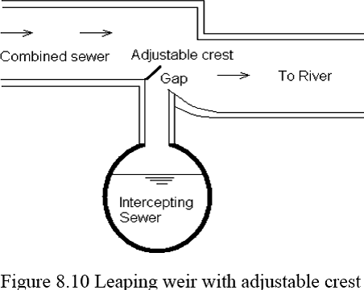
Leaping Weir:- The term leaping weir is used to indicate the gap or opening in the invert of a combined sewer. The leaping weir is formed by a gap in the invert of a sewer through which the dry weather flow falls and over which a portion of the entire storm leaps. This has an advantage of operating as regulator without involving moving parts. However, the disadvantage of this weir is that, the grit material gets concentrated in the lower flow channel. From practical consideration, it is desirable to have moving crests to make the opening adjustable. When discharge is small, the sewage falls directly into the intercepting sewer through the opening. But when the discharge exceeds a certain limit, the excess sewage leaps or jumps across the weir and it is carried to natural stream or river. This arrangement is shown in the Figure below.
- Float Actuated Gates and Valves:-The excess flow in the sewer can also be regulated by means of automatic mechanicalregulators. These are actuated by the float according to the water level in the sump interconnected to the sewers. Since, moving part is involved in this, regular maintenance of
this regulator is essential.
4 Siphon Spillway:-This arrangement of diverting excess sewage from the combined sewer is most effective because it works on the principle of siphon action and it operates automatically. The overflow channel is connected to the combined sewer through the siphon. An air pipe is provided at the crest level of siphon to activate the siphon when water will reach in the combined sewer at stipulated level (Fig.below).
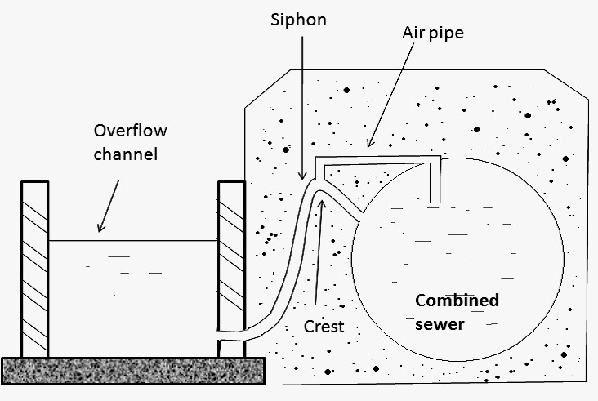
Catch Basins: Catch basins are small settling chambers of diameter 60 - 90 cm and 60 - 75 cm deep, which are constructed below the street inlets. They interrupt the velocity of storm water entering through the inlets and allow grit, sand, debris and so on to settle in the basin, instead of allowing them to enter into the sewers.
FLUSHING TANKS:These are masonary or concrete chambers to flush the sewers when the sewers gradients are flat and velocity of sewage is very low. These are usually provided at the beginning point of the sewers and may be either are automatic or worked by hand. In automatic flushing tank, the water is automatically released from the tank at required intervals, which can be
adjusted by supply tap and flushes the sewer as shown in fig below. It consists of U-tube with bell cap at its one end connects the chamber with sewer. With the water level reaches certain level in
the chamber, siphonic action takes place and the whole water of the chamber rushes to the sewer pipe and flushes it. The capacity of these tanks is usually 9 to 14 litre and may be adjusted in such
a way as to work twice or thrice a day depending upon the quantity of deposits in the sewer and size of sewer.
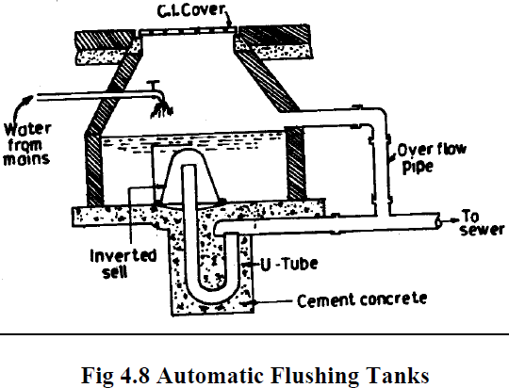

INVERTED SIPHONS:-
An inverted siphon or depressed sewer is a sewer that runs full under gravity flow at a pressure above atmosphere in the sewer due to flow line being below the hydraulic grade line.
PURPOSE:They are constructed when a sewer crosses a stream or deep cut or road or railway line, to pass under obstacles such as buried pipes, subways, etc (Fig. 8.5). This terminology ‘siphon’ is misnomer as thereis no siphon action in the depressed sewer. As the inverted siphon requires considerable attention for maintenance, it should be used only where other means of passing an obstacle in line of the sewer are impracticable.
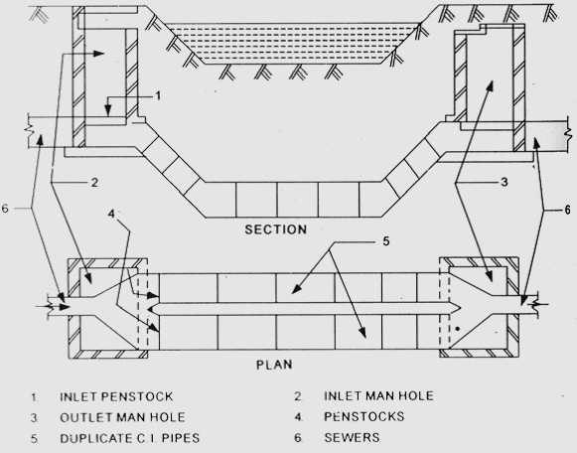
The main purpose of inverted siphon is to carry the sewerline below obstructions such as ground depressions, streams, rivers, railway etc.
Siphon is so designed that a self-cleaning velocity of about 90cm/sec during achieved the period of minimum discharge. For this purpose, the siphon is usually made of three pipe sections-one for carrying minimum discharge, the other for maximum discharge and the third for combined flow in mansoons. The inlet chamber contains three channels, one for each pipe section. When channel no. 1 overflows, the sewage enters in channel no. 2 and pipe no. 2 comes into commission. Similarly, when channel no. 2 also overflows the sewage enters channel no. 3 and pipe no. 3 comes into commission as shown in fig. The inlet chamber should be provided with screens to remove silt, grit etc from sewage before enters the siphon
To clean the siphon pipe sluice valve is opened, thus increasing the head causing flow. Due to increased velocity deposits of siphon pipe are washed into the sump, from where they are removed.

DISADVANTAGES OF SIPHON:
- As the down gradient is not continuous in inverted siphon; the silting takes place.
- It is not possible to give side connections to inverted siphons.
- If inlet chamber is not properly designed, the floating matter contained in sewage will separate out and it will accumulate in the inlet chamber results in the inefficient functioning of the inverted siphon. SEWER VENTILATORS
Ventilation to the sewer is necessary to make provision for the escape of air to take care of the exigencies of full flow and to keep the sewage as fresh as possible. In case of stormwater, this can be done by providing ventilating manhole covers. In modern sewerage system, provision of ventilators is not necessary due to elimination of intercepting traps in the house connections allowing ventilation.

Unit-04/Lecture-10
Sewage pumping - location of pumping station and types of pumps
Pumping of Sewage:- NECESSITY OF PUMPING SEWAGE-LOCATION AND COMPONENT PARTS OF PUMPING STATION.
In sewerage system at some places the sewage cannot flow under its gravitational force only and requires lifting in following circumstances, it is becomes necessary to pump the sewage.
- Low-laying area of town where sewage cannot flow by gravity.
- In basements of buildings, the sewage is pumped to the sewerline.
- If a ridge intervenes, sometimes it is economical to pump sewage,instead of providing a tunnel.
- When the land is flat and it not possible to get self-cleaning velocity, the sewers are laid at the required slope and after some interval they are allowed to flow under gravity.
- At the treatment plants to rise it upto the plant for treatment.
- At the outfall while disposing it is required to be pump if the level of the water course is higher than the outlet of the sewer.

LOCATION OF PUMPING STATION:
The following points should be considered while locating the site of pumping station
- The topographical conditions of the city should be thoroughly studied to locate the best site of pumping station
- If the quantity of sewage is very large, the site should be near to the disposal point or at a place (near a stream; or a nallah or a storm water drain ) where the sewage can be directly disposed off during emergencies
- The site should be such that during flexed, it should not flooded with river water or seepage from the ground.
- Provision should be made to pump all the sewage which will be received during worst conditions of rains.
- The station be so located that it is easily accessible under all weather conditions.

ELEMENTS OF PUMPING STATION: 1. Preliminary screening and grit chambers
- Sump or wet well
- Pumproom or dry well
- Pumps with driving engine or motar
- Miscellaneous accessories such as pipes, valves, fittings, flow recorder, emergency over-flow etc The capacity of pumping station is determined by the present and future sewage flows based on a designed period of 15years. While designing the pump house, provisions should be made for easy removal and installation of pumps and motars for periodical repairs and replacements
- PRELIMINARY SCREENING AND GRIT CHANNELS:Large amount of sand, gravel , rags , paper, leaves etc should be removed before pumping so as to prevent the wear and tear of pumping machinery and increasing its life, by passing the sewage through flat bar screens & then into grit channel where heavier inorganic solid matters settles.
- SUMP OR WET WELL:The sewage from the city is received at pumping station in a tank known as sump or wet well, is an underground, ring or circular shape placed at such a level that sewage from trunk sewer can flow into it by gravity only, bottom of the tank is given a 1:1 slope towards a central pit where the end of section pipe of the pump is placed. The depth of the well depends upon the depth of incoming sewage of inlet. Gate valves should be fitted on the incoming sewer lines to stop the sewage flow during inspection , repairs and cleaning of the wet well etc. At the top of the wet well manhole with ladders are provided for cleaning, inspection and maintenance as shown in fig .

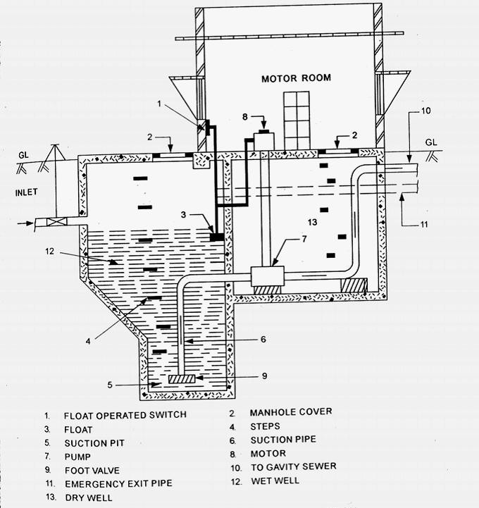
- PUMP ROOM: is also called as dry-well and placed in a convenient location such that the pumps can easily function, is an underground masonary and sewage pumps, their driving units, control valves etc are installed in it sufficient size for the movement of operator , maintenance repair and installation of pumps etc.

PIPES VALVES, FITTINGS etc:
(iv) PUMPS WITH DRIVING ENGINE OR MOTOR:Requirements of good sewage pump.
- can pump the sewage upto required elevation.
- can pump the required quantity of sewage even in emergency period.
- Reliable.
- Cheap in initial cost and maintenance.
- Noncorrosive by the organic and inorganic wastes of the sewage.
- Should not be damaged or worn out by the presence of sand ,gravel, stone etc in the sewage. 7.Less spacing for installation.
- Less noise during working.
- Userfriendly in its maintenance and operation.
Generally centrifugal pumps are used for pumping of sewage provided with automatic or remote control devices and fulfill most of the requirements of the sewage pumps.
The pumps can be placed
- Directly in the wet well in the submerged position
- In the dry well above the sewerage level in the wet well driving unit is gasoline or steam engine
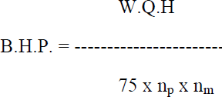
- In the dry well below the sewage level in the wet well driving unit is electric motar The B.H.P of the driving unit is calculated by the formula,
where Q = discharge H = Water head
n_{p} = efficiency of pump
n_{m} = efficiency of driving engine of motar
Types of pumps :Following are the types of pumps commonly used for sewage pumping :
- Centrifugal pumps. either axial, mixed and radial flow. (ii) Reciprocating pumps.(Ram type,Propeller type) (iii) Propeller or axial flow pumps. and (iv) Air pressure pumps or ejectors.,
( v)Pneumatic ejector pumps.
SAFETY MEASURES:to be taken at the sewage pumping stations
- Railng should be provided around manholes and openings
- Gaurds should be provided on and around all mechanical equipment
- Staircases with landing should be provided in place of ladders.
- The steps of the stair cares should be of non-slippery to prevent slippage
- Fire extinguishers first aid boxes and other safety devices should be provided

- To prevent explosure gas leakage, wet well should not be directly connected by any opening to dry well or super structure.
- All electrical equipment and wiring should be properly insulated and grounded.
- To minimize the possibilities of cross connectors, the pipes should be given different colours.

House plumbing systems, sanitary fitting and appliances, traps, anti-syphonage, inspection chambers and intercepting traps.
The arrangement provided in a house or building, for Collecting and Conveying wastewater through drain pipes, by gravity, to join either a public Sewer or a domestic septic tank, is termed as house drainage or .building drainage.
Aims of house drainage. drainage is provided
(1) to maintain healthy conditions
- to dispose off waste water at the earliest
- to avoid the entry of foul gases from the Sewer or the Septic tank
- to facilitate quick removal of foul matter (e.g. human excrcta) (i’) To collect and remove waste matters Systematically.
PIPES AND TRAPS
Pipes. In a house drainage system, a pipe may have the following designations, depending upon the function it carries :
- Soil pipe. A soil pipe is a pipe through which human cxcrcta flOWS.
- Waste pipe.. It is a pipe which carries only the liquid wastc. It does not carry human excreta.
- Vent pipe. It is a pipe which is provided for the purposc of the ventilation of the systcm. A vent pipe is open at top and bottom, to facilitate exit of foul gases. It is carried at least 1 m highcr than the roof level.
- Rain water pipe. It is a pipe which carries only the rain water.
- Anti-siphonac pipe. It is pipe which is installed in the house drainage ‘to preserve the water seal of traps.
The following sizes of pipes are commonly used in house drainage :
Soil pipe : 100 mm
Waste pipe : horizontal : 30 to 50 mm Waste pipe : vertical : 75 mm
Rain water pipe : 75 mm Vent pipe : 50 mm
Anti-siphonage pipe : (i) Connecting soil pipe : 50 mm
- Connecting waste pipe : 40 mm
Traps. :- is a depressed or bent fitting which, when provided in a drainage system, always remains full of water, thus maintaining a water seal, prevents the passage of foul air or gas through it, but allows the sewage or waste water to flow through it. The depth of water seal is the vertical distance between the crown and dip of a trap (Fig. 20.1) represents its strength or effectiveness. Greater the depth of water seal, more effective is the trap. The depth of water seal varies from 25 mm to 75 mm.
Causes of breaking of seal . Water seal may break due to the following reasons :
  - faulty joints
- crack in the bottom of seal
- creation of partial vacuum in the sewer fittings
- increase in the pressure of sewer gases, and
- non-use for a prolonged period.
The breaking of the water seal can be prevented by (i) connecting thc portion between the soil pipe and trap by a vent pipe, and (ii) use of anti-siphonage pipe in the building.
Characteristics of traps. A trap should possess :
- adequate water seal at all times, to fulfill the purpose of its installation. However, it should retain
minimum quantity àf water for this purpose.
- It should be of non-absorbent material.
- It should be free from any inside projections, angles or contractions, so that flow is not obstructed or retarded.
- It should be simple in construction, cheap and readily available.
- It should be self cleansing.
- It, should bc provided with suitable access for cleaning.
- Its internal and external surfaces should have smooth finish so that dirt etc. does not stick to it.
CLASSIFICATION OF TRAPS :- are as follows :
- Classification according to shape (Fig. 20.1)
- P-Trap (Fig. 20.1 a). This resembles the shape of letter P,in which the legs are at right angles to each other.
- Q-trap or half-S-trap (Fig. 20.1 b). This resembles the of letter Q, in which the two legs meet at an angle other than a right angle.
- S-trap (Fig. 21.6 c). This resembles letter-S, in which both the legs are parallel to each other, discharging in the same direction. Fig. 20.1 (d) shows the development of all the thrcc types of traps.

Classification according to use
  - Floor trap or nahni trap
- Gully trap
- Intercepting trap.
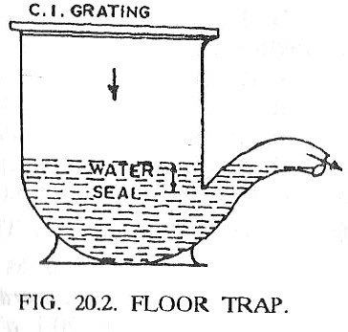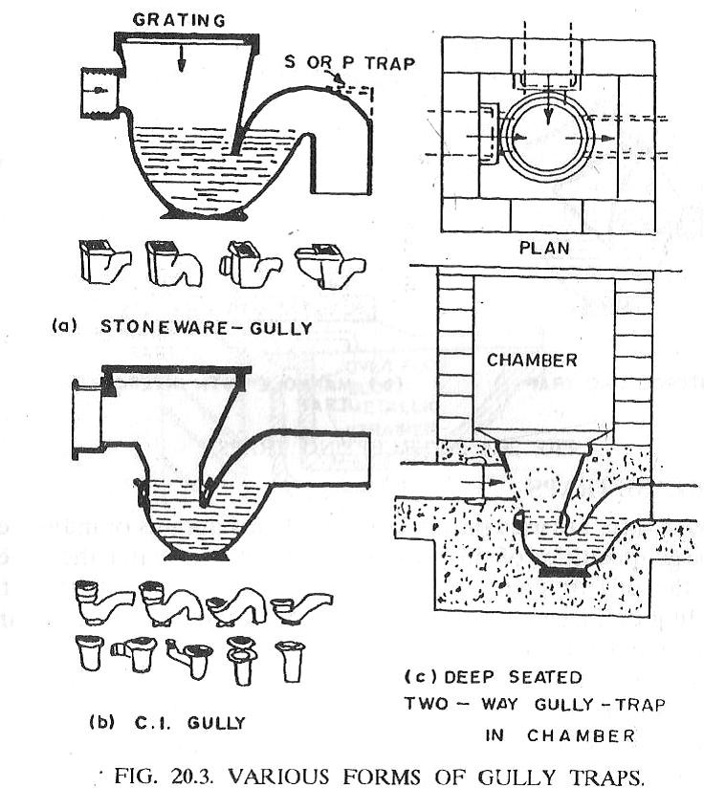 FLOOR TRAP OR NAIINI TRAP :-is used to collect wash water from floors, kitchens and bath rooms, starting Point of waste water floor,made of cast iron, with a gravity at tip, to exclude entry of ‘solid matter of big size. This cover can be removed to do frequent cleaning of the trap. These traps F have small water seal.
GULLY TRAP :-special types of traps which disconnect sullage drain (collected from baths, kitchen etc.) from the main drainage system, is either made of stone-ware or of cast iron. Stone ware gully trap is of square section at the top on which C.I. grating is fitted. A well designed gully trap may serve two or three connections from nahni traps.
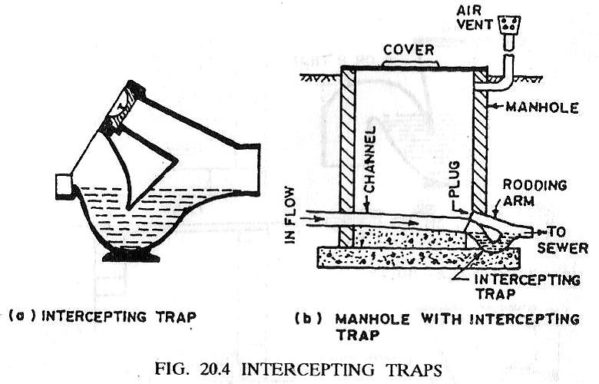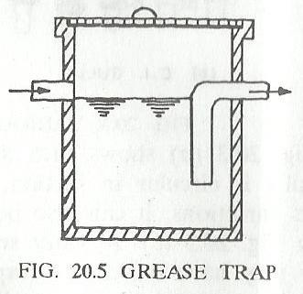INTERCEPTING TRAPS :- special type of trap provided at the junction of house drain with the public sewer or septic tank. It is thus provided in the last manhole of the house drainage system. It has a dcep water seal of 100 mm, so as to effectively prevent the entry of sewer gases from public sewer line into the house drain.The trap has an opening at the top, called the cleaning eye or rodding arm, having a tight fitting plug, for frequent cleaning of the trap.
GREASE TRAPS :- used only in large hotels, restaurants or industries where large quantities of oily wastes arc cxpccted to enter the water flow. If the oily or greasy matter is not separated, it will stick to the building drainage system resulting in the formation of ugly scum and consequent obstruction to reaeration. A grease trap is either a masonry or cast iron chamber, with a bent pipe or Tee-pipe at the outlet end. Because of sudden increase in the area of flow at entry, the velocity of flow is reduced, resultingin the separation of oily and greasy matter from the wastewater. This greasy matter, floating on the lop can be removed later.

Questions
- Explain the factors affecting the storm water discharge.
- What is time of concentration? What is its role in determination of the storm water runoff?
- Explain critical rainfall duration. Why rainfall of this duration will generate maximum runoff?
- Write short notes on the estimation of storm water runoff.
- What is coefficient of runoff?
- A catchment is having total area of 60 hectares. The rainfall intensity relation with duration for this catchment is given by the relation I = 100/(t+20), where I is in cm/h and t is duration of rain in min. (A) Draw the graph of rainfall intensity relation with duration at 10 min interval? (B) What will be the storm water runoff from this catchment if the average imperviousness factor is 0.63, and time of concentration is 35 min? (C) If population density of the area is 350 persons per hectare and water consumption is 170 LPCD, what will be the design discharge for separate system and combined system?

Questions
- Write about evaluation of design discharge for sanitary sewage.
- What is dry weather flow?
- Describe variation in sewage flow. How design of different component of sewerage scheme will be affected due to this variation?
- What is design period? It depends on what parameters? Provide design period for different components of the sewerage.
- Describe in brief various types of water carriage systems.
- Describe merits and drawback of separate system, partially separate system and combined system.
- What are the considerations while finalizing the type of sewerage system?
- Write about various patterns of collection system.

Questions
1. Define sewer appurtenances. What are the appurtenances used in sewerage?
- Describe different types of Manholes used in collection system.
- When the drop manhole is used in sewers?
- Describe different types of storm water inlets used in collection system.
- Why flow regulator device is used in sewers? Describe different types of regulators used.
Explain various principles that should be kept in mind while designing a house drainage system.
- Explain the terms : soil pipe ; waste pipe ; vent pipe
- What is meant by anti-siphonage pipe 7 Explain its function with a neat sketch.
- Explain various types of traps commonly used.
- (a) Explain in brief various types of water closets.
(b) Enumerate the requirements of a good water closet.
- Explain, with the help of a diagram, the working of a flushing àistern..
- Explain, with the help of diagrams, various systems of plumbing used for house drainage.

