Unit 4

Mobile Internet Protocol (or Mobile IP)
Mobile IP is a communication protocol (created by extending Internet Protocol, IP) that allows the users to move from one network to another with the same IP address. It ensures that the communication will continue without user’s sessions or connections being dropped. This is an IETF (Internet Engineering Task Force) standard communications protocol designed to allow mobile devices' (such as laptop, PDA, mobile phone, etc.) users to move from one network to another while maintaining their permanent IP (Internet Protocol) address.
Defined in RFC (Request for Comments) 2002, mobile IP is an enhancement of the internet protocol (IP) that adds mechanisms for forwarding internet traffic to mobile devices (known as mobile nodes) when they are connecting through other than their home network.

Terminologies:
- Mobile Node (MN):
It is the hand-held communication device that the user caries e.g. Cell phone.
- Home Network:
- It is a network to which the mobile node originally belongs to as per its assigned IP address (home address).
- Home Agent (HA):
It is a router in home network to which the mobile node was originally connected
- Home Address:
It is the permanent IP address assigned to the mobile node (within its home network).
- Foreign Network:
It is the current network to which the mobile node is visiting (away from its home network).
- Foreign Agent (FA):
It is a router in foreign network to which mobile node is currently connected. The packets from the home agent are sent to the foreign agent which delivers it to the mobile node.
- Correspondent Node (CN):
It is a device on the internet communicating to the mobile node.
- Care of Address (COA):
It is the temporary address used by a mobile node while it is moving away from its home network.
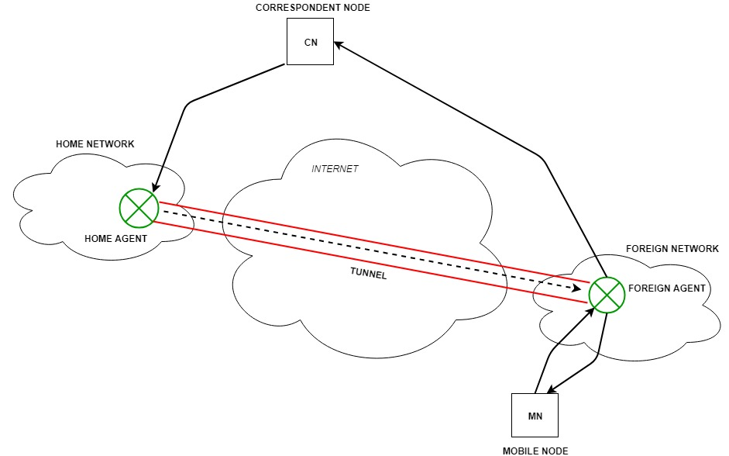

Working:
Correspondent node sends the data to the mobile node. Data packets contains correspondent node’s address (Source) and home address (Destination). Packets reaches to the home agent. But now mobile node is not in the home network, it has moved into the foreign network. Foreign agent sends the care-of-address to the home agent to which all the packets should be sent. Now, a tunnel will be established between the home agent and the foreign agent by the process of tunneling.
Tunneling establishes a virtual pipe for the packets available between a tunnel entry and an endpoint. It is the process of sending a packet via a tunnel and it is achieved by a mechanism called encapsulation.
Now, home agent encapsulates the data packets into new packets in which the source address is the home address and destination is the care-of-address and sends it through the tunnel to the foreign agent.
Foreign agent, on other side of the tunnel receives the data packets, decapsulates them and sends them to the mobile node. Mobile node in response to the data packets received, sends a reply in response to foreign agent. Foreign agent directly sends the reply to the correspondent node.
Key Mechanisms in Mobile IP:
- AgentDiscovery:
Agents advertise their presence by periodically broadcasting their agent advertisement messages. The mobile node receiving the agent advertisement messages observes whether the message is from its own home agent and determines whether it is in the home network or foreign network.
- Agent Registration:
Mobile node after discovering the foreign agent, sends registration request (RREQ) to the foreign agent. Foreign agent in turn, sends the registration request to the home agent with the care-of-address. Home agent sends registration reply (RREP) to the foreign agent. Then it forwards the registration reply to the mobile node and completes the process of registration.
- Tunneling:
It establishes a virtual pipe for the packets available between a tunnel entry and an endpoint. It is the process of sending a packet via a tunnel and it is achieved by a mechanism called encapsulation. It takes place to forward an IP datagram from the home agent to the care-of-address. Whenever home agent receives a packet from correspondent node, it encapsulates the packet with source address as home address and destination as care-of-address.
Route Optimization in Mobile IP:
The route optimization adds a conceptual data structure, the binding cache, to the correspondent node. The binding cache contains
- bindings for mobile node’s home address and its current care-of-address. Every time the home agent receives a IP datagram that is destined to a mobile node currently away from the home network, it sends a binding update to the correspondent node to update the information in the correspondent node’s binding cache. After this the correspondent node can directly tunnel packets to the mobile node.

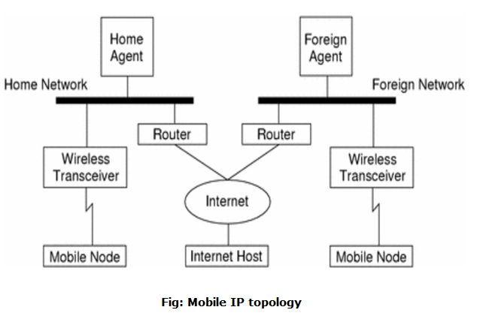

Process of Mobile IP
The mobile IP process has following three main phases, which are:

1. Agent Discovery
During the agent discovery phase the HA and FA advertise their services on the network by using the ICMP router discovery protocol (IROP).
Mobile IP defines two methods: agent advertisement and agent solicitation which are in fact router discovery methods plus extensions.
- Agent advertisement: For the first method, FA and HA advertise their presence periodically using special agent advertisement messages. These messages advertisement can be seen as a beacon broadcast into the subnet. For this advertisement internet control message protocol (ICMP) messages according to RFC 1256, are used with some mobility extensions.
- Agent solicitation: If no agent advertisements are present or the inter arrival time is too high, and an MN has not received a COA, the mobile node must send agent solicitations. These solicitations are again bases on RFC 1256 for router solicitations.

2. Registration
The main purpose of the registration is to inform the home agent of the current location for correct forwarding of packets.
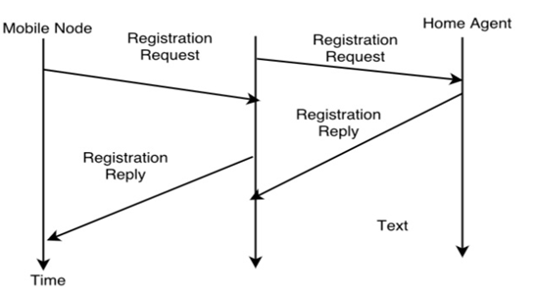
Registration can be done in two ways depending on the location of the COA.
- If the COA is at the FA, the MN sends its registration request containing the COA to the FA which is forwarding the request to the HA. The HA now set up a mobility binding containing the mobile node's home IP address and the current COA.
Additionally, the mobility biding contains the lifetime of the registration which is negotiated during the registration process. Registration expires automatically after the lifetime and is deleted; so a mobile node should register before expiration. After setting up the mobility binding, the HA send a reply message back to the FA which forwards it to the MN.
- If the COA is co-located, registration can be very simpler. The mobile node may send the request directly to the HA and vice versa. This by the way is also the registration procedure for MNs returning to their home network.

3. Tunneling
A tunnel is used to establish a virtual pipe for data packets between a tunnel entry and a tunnel endpoint. Packets which are entering in a tunnel are forwarded inside the tunnel and leave the tunnel unchanged. Tunneling, i.e., sending a packet through a tunnel is achieved with the help of encapsulation.
Tunneling is also known as "port forwarding" is the transmission and data intended for use only within a private, usually corporate network through a public network.

