NOTES FOR STUDIES
NAME OF THE TEACHER | VEENA MANDLEKAR
SUBJECT | ADVANCE SURVEYING
SUBJECT CODE | CE401
UNIT NO. | 3
TOPIC NAME | TECHOMETRIC SURVEY
DEPARTMENT | LNCTS, CIVIL ENGG.
INTENDED FOR | 4TH SEMESTER DIPLOMA

UNIT 3 TECHOMETRIC SURVEY

Tacheometric is a branch of surveying in which horizontal and vertical distances are determined by taking angular observation with an instrument known as a tachometer. Tacheometric surveying is adopted in rough in rough and difficult terrain where direct leveling and chaining are either not possible or very tedious. The accuracy attained is such that under favorable conditions the error will not exceed 1/100. and if the purpose of a survey does not require accuracy, the method is unexcelled. Tacheometric survey also can be used for Railways, Roadways, and reservoirs etc. Though not very accurate.
Tacheometric surveying is very rapid, and a reasonable contour map can be prepared for
investigation works within a short time on the basis of such survey.

Uses of Tachometry
Tachometry is used for
preparation of topographic map where both horizontal and vertical distances are required to be measured;
survey work in difficult terrain where direct methods of measurements are inconvenient;
reconnaissance survey for highways and railways etc; Establishment of secondary control points.

Instruments used in tachometric surveying
An ordinary transits theodolite fitted with a stadia diaphragm is generally used for tacheometric surveying. The stadia diaphragm essentially consists of one stadia hair above and the other an equal distance below the horizontal cross hair, the stadia hair being mounted in the same ring and in the same vertical plane as the horizontal and vertical cross-hair.
The telescope used in stadia surveying are three kinds, The Simple external focusing telescope.
The external focusing anal lactic telescope (porro’s telescope). The internal focusing telescope.

The first type is known as stadia theodolite, while the second type is known as tacheometer. The tacheometer has the advantage over the first and third type due to fact that the additive constant of the instrument is zero.

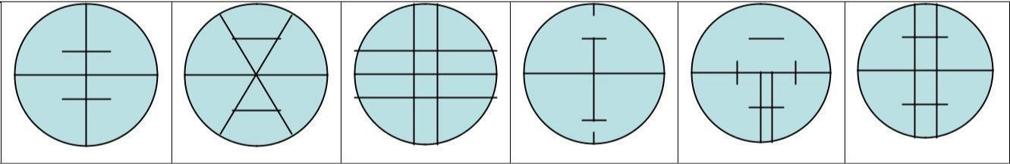

The instruments employed in tachometry are the engineer's transit and the leveling rod or stadia rod, the theodolite and the subtense bar, the self- reducing theodolite and the leveling rod, the distance wedge and the horizontal distance rod, and the reduction tacheometer and the horizontal distance rod.

Features of tacheometer or Characteristic of tacheometer

The multiple constant (f/i) should have a normal value of 100 and the error contained in this value should not exceed 1 in 1000.
The axial horizontal lines should be exactly midway between the other two lines. The telescope should be fitted with an anallatic lens to make the additive constant (f + d) exactly to zero.
The telescope should be truly analectic.
The telescope should be powerful having a magnification of 20 to 30 diameters. The Aperture of the object should be 35 to 45 mm in diameter.

Levelling and Stadia Staff Rod
For short distances, ordinary leveling staves are used. The leveling staff normally 4m long, and it can be folded with here parts. The graduations are so marked that a minimum reading of 0.005 or 0.001m can be taken.

Different systems of Tacheometric Measurement
The various systems of tacheometric survey may be classified follows, The Stadia Method
- Fixed Hair Method and
- Movable Hair Method

The Tangential System
Measurements by means of special instruments.
The principle is common to all system is to calculate the horizontal distance between two points A and B their deference in elevation, by observing 1) the angle at the instrument at A subtended by known short distance a long a staff kept at B and 2) the vertical angle to B from A

Stadia systems
In this systems staff intercepts, at a pair of stadia hairs present at diaphragm, are considered. The stadia system consists of two methods:
- Fixed- hair method and
- Movable-hair method

Fixed-hair method
In this method, stadia hairs are kept at fixed interval and the staff interval or intercept (corresponding to the stadia hairs) on the leveling staff varies. Staff intercept depends upon the distance between the instrument station and the staff.

Movable- hair method
In this method, the staff interval is kept constant by changing the distance between the stadia hairs. Targets on the staff are fixed at a known interval and the stadia hairs are adjusted to bisect the upper target at the upper hair and the lower target at the lower hair. Instruments used in this method are required to have provision for the measurement of the variable interval between the stadia hairs. As it is inconvenient to measure the stadia interval accurately, the movable hair method is rarely used.

Non-stadia systems
This method of surveying is primarily based on principles of trigonometry and thus telescopes without stadia diaphragm are used. This system comprises of two methods:

Tangential method and
- Subtense bar method. Tangential method
In this method, readings at two different points on a staff are taken against the horizontal cross hair and corresponding vertical angles are noted.

Subtense bar method.
In this method, a bar of fixed length, called a subtense bar is placed in horizontal position. The angle subtended by two target points, corresponding to a fixed distance on the subtense bar, at the instrument station is measured. The horizontal distance between the subtense bar and the instrument is computed from the known distance between the targets and the measured horizontal angle.

Principles of Stadia Method
(Figure 23.1) A tacheometer is temporarily adjusted on the station P with horizontal line of sight. Let a and b be the lower and the upper stadia hairs of the instrument and their actual vertical separation be designated as i. Let f be the focal length of the objective lens of the tacheometer and c be horizontal distance between the optical centre of the objective lens and the vertical axis of the instrument. Let the objective lens is focused to a staff held vertically at Q, say at horizontal distance D from the instrument station.
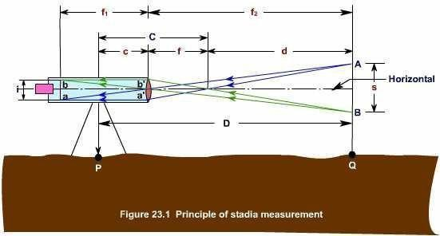
By the laws of optics, the images of readings at A and B of the staff will appear along the stadia hairs at a and b respectively. Let the staff interval i.e., the difference between the readings at A and B be designated by s. Similar triangle between the object and image will form with vertex at the focus of the objective lens (F). Let the ho rizontal distance of the staff from F be d. Then, from the similar Ds ABF and a' b' F,

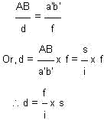
as a' b' = ab = i. The ratio (f / i) is a constant orf a particular instrument and is known as stadia interval factor, also instrument constant. It is denoted by K and thus
d = K.s Equation (23.1)

The horizontal distance (D) between the center of the instrument and the station point (Q) at which the staff is held is d + f + c. If C is substituted for (f + c), then the horizontal distance D from the center of the instrument to the staff is given by the equation
D = Ks + C Equation (23.2)

The distance C is called the stadia constant. Equation (23.2) is known as the stadia equation for a line of sight perpendicular to the staff intercept.

Theory of Stadia Tacheometry
The following is the notation used in stadia tacheometry

O |  | = | Optical centre of object glass.
A 1, A 2, C |  | = | Readings on staff cut by three hairs
a 1, a 2, | C | = | Bottom T op, a nd Central Hair of dia phra gm
a 1 a 2, = | i | = | length of image
A 1, A 2, = S |  | = | Staff Intercept
V |  | = | Vertical axis of instrument

 | A1
a2
O
i c1 V | C | S
a1
d | A2
f

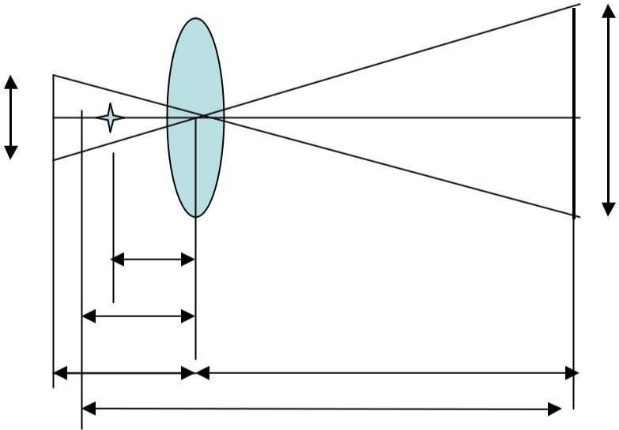
f =Focal length of a object glass
v
u
D
d =distance between optical centre and vertical axis of instrument
u=distance between optical centre and staff v=distance between optical centre and image.
F or s imilar tria ngles a 1, O a 2 an d A 1 , OA 2,
i |  | v |  | iu
—  s | = | —  u | or v = | —  ------  s

-----------------------
(1)

From the properties of length,

1 1 1

— + — = —
v u f
Putting the value of v in Eq. (2)
- - - -- - -- - -- - -- - -- - -- - -- - -- - --

1 1 1
— +— = —

(2)

iu/s u f
Or
s 1 1
— +— = —
iu u f
Or
1 s 1
— {— + 1 } = —
u i f

Or
s
u = {— + 1}
f i

But, D = u + d (3)

s
D = {— + 1} f +
d i
s f
— x f + f + d = {— }x s + (f +
d) i i

The quanta ties (f/i) and (f + d) are known as techeometric constants. (f/i) is called the multiplying constant, as already stated, and (f + d) the additive constant. by adopting an anal latic lens in the telescope of a tacheometric, the multiplying constant is made 100, and the additive constant zero. However, in some tacheometers the additive constants are not exactly zero, but vary from 30 cm to 60 cm

Inclined Stadia Measurements
It is usual that the line of sight of the tacheometer is inclined to the horizontal.
Thus, it is frequently required to reduce the inclined observations into horizontal distance and difference in elevation.
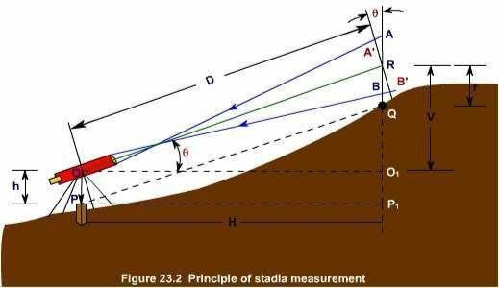

Let us consider a tacheometer (having constants K and C) is temporarily adjusted on a station, say P (Figure 23.2). The instrument is sighted to a staff held vertically, say at Q. Thus, it is required to find the horizontal distance PP1 (= H) and the difference in elevation P1Q. Let A, R and B be the staff points whose images are formed respectively at the upper, middle and lower cross hairs of the tacheometer. The line of sight, corresponding to the middle cross hair, is inclined at an angle of elevation q and thus, the staff with a line perpendicular to the line of sight. Therefore A'B' = AB cos q = s cos q where s is the staff intercept AB. The distance D (= OR) is C + K. scos q (from Equation 23.2). But the distance OO1 is the horizontal distance H, which equals OR cos q.
Therefore the horizontal distance H is given by the equation.

H = (Ks cos q + C) cos q

Or H = Ks cos2 q + C cos q Equation (23.3)

in which K is the stadia interval factor (f / i), s is the stadia interval, C is the stadia constant (f + c), and q is the vertical angle of the line of sight read on the vertical circle of the transit.

The distance RO1, which equals OR sin q, is the vertical distance between the telescope axis and the middle cross- hair reading. Thus V is given by the equation

V = ( K s c os q + c) s in q
V = Ks sin q cos q + C sin q ----------------- | Equa tion ( 23. 4)
-- -
Equation (23.5)

Thus, the difference in elevation between P and Q is (h + V - r), where h is the height of the instrument at P and r is the staff reading corresponding to the middle hair.

Uses of Stadia
The stadia method of surveying is particularly useful for following cases:
- In differential leveling, the back sight and foresight distances are balanced conveniently if the level is equipped with stadia hairs.
- In profile leveling and cross sectioning, stadia is a convenient means of finding distances from level to points on which rod readings are taken.
- In rough trigonometric, or indirect, leveling with the transit, the stadia method is more rapid than any other method.
- For traverse surveying of low relative accuracy, where only horizontal angles and distances are required, the stadia method is a useful rapid method.
- On surveys of low relative accuracy - particularly topographic surveys-where both the relative location of points in a horizontal plane and the elevation of these points are desired, stadia is useful. The horizontal angles, vertical angles, and the stadia interval are observed, as each point is sighted; these three observations define the location of the point sighted.

Errors in Stadia Measurement
Most of the errors associated with stadia measurement are those occur during observations for horizontal angles (Lesson 22) and differences in elevation (Lesson 16). Specific sources of errors in horizontal and vertical distances computed from observed stadia intervals are as follows:

Error in Stadia Interval factor
This produces a systematic error in distances proportional to the amount of error in the stadia interval factor.

Error in staff graduations
If the spaces on the rod are uniformly too long or too short, a systematic error proportional to the stadia interval is produced in each distance.

Incorrect stadia Interval
The stadia interval varies randomly owing to the inability of the instrument operator to observe the stadia interval exactly. In a series of connected observations (as a traverse) the error may be expected to vary as the square root of the number of sights. This is the principal error affecting the precision.

